# Online Banking Specification

**Version 19**

# Table of Contents

**Online Banking Specification**1

**Table of Contents**2

**Revision History**3

**Introduction**5

Typographic Conventions and Acronyms 5

**Description of the System**7

1. Admin Application 7

1.1. Login Page 7

1.2. Customers - Search screen (default view) 8

1.3. Customers - Search screen (with search results) 10

1.4. Add Customer screen 11

1.5. Edit Customer screen 26

1.6. Add Account screen 30

1.7. View Account screen 33

1.8. Edit Account screen 35

1.9. Deactivate Account pop-up window 38

1.10. Add Card screen 39

1.11. View Card screen 42

1.12. Edit Card screen 44

1.13. Deactivate Card pop-up window 45

1.14. Reports Screen 46

2. Customer Application 50

2.1. Login Page 50

2.1.1. Forgot Password? pop-up window 52

2.1.2. Change Password page (at login) 54

2.2. Main Page 55

2.3. Accounts Page 57

2.4. Account Details pop-up 61

2.5. Cards Page 64

2.6. Card Details pop-up 68

2.7. Money Transfer pop-up 71

**Styling Rules**78

Rules applying to error messages 78

Rules applying to input fields 80

# Revision History

|  |  |  |  |
| --- | --- | --- | --- |
| **Author** | | Eugenia Ostrovska | |
| **Last Revision Date** | | 2017-05-15 | |
| **History of revisions** | | | |
| **Date** | **Author** | | **Description** |
| 2017-04-20 | Eugenia Ostrovska | | Document created with description of Customer Application (sections 2.1 and 2.2). |
| 2017-04-27 | Eugenia Ostrovska | | Typographic Conventions and Acronyms section added.  Description of Admin Application (sections 1.1 and 1.2) added. |
| 2017-05-02 | Eugenia Ostrovska | | Section 1.3 is added to description of Admin Application. |
| 2017-05-05 | Eugenia Ostrovska | | Section 1.4 is added to description of Admin Application. |
| 2017-05-08 | Eugenia Ostrovska | | BRAAC021, BRAAC021 are corrected.  **Default State** is added for each element.  Description of **Email** in Admin Application Add Customer Table of Elements is corrected.  Description of **Default Password** in Admin Application Add Customer Table of Elements is corrected.  BRAAC044 is corrected, BRAAC045 is added.  Numbers BRAAC045 - BRAAC050 are corrected to BRAAC046 - BRAAC051.  Description of **Customer Search Results** table in Admin Application Customers Search Results Table of Elements (at least one customer is found) is updated.  Section 1.5 is added to description of Admin Application. |
| 2017-05-10 | Eugenia Ostrovska | | BRAAC052 - BRAAC054 are added.  Description of **Codeword** in Admin Application Add Customer Table of Elements is corrected.  **Styling Rules** section is added. |
| 2017-05-15 | Eugenia Ostrovska | | Content mistake in description of BRALP004 is corrected.  Description of **Login** and **Password** in Admin Application Login Page Table of Elements is updated.  Description of BRAAC004, BRAAC007, BRAAC052 is updated.  BRAAC055 and BRAAC056 are added.  Minor grammar mistakes in BRAAC039 and BRAAC047 are corrected. |
| 2017-05-16 | Oksana Atanasova | | Sections 1.6-1.13 are added to description of Admin Application.  Minor changes to Add Card, Add Account buttons’ descriptions in section 1.4. Description of BRAAC057 is added. |
| 2017-05-25 | Oksana Atanasova | | BRAAC004, 005, 007, 008, 027, 028, 030, 031, 033, 034, 052, 053 - minor updates in error message text to avoid ambiguity. |
| 2017-05-28 | Oksana Atanasova | | Removed BRAAA009 in section 1.8. Updated View Card UI mock-up in section 1.11. Added description of **Back** button. Added description of **Save** and **Cancel** buttons in 1.12.  Other minor changes highlighted in yellow. |
| 2017-05-30 | Oksana Atanasova | | Minor updates in BRAEA001 description and BRAEA002 duplicate updated. Update in BRAAPC014. |
| 2017-06-02 | Oksana Atanasova | | Changed default value for Card Number to Empty in section 1.10. Fixed Error message description for BRAAPC013 in section 1.10.  Updated label in UI mockup for Edit Card screen in section 1.12.  Minor updates in descriptions of Save button in sections 1.6, 1.8, 1.10, 1.12.  Added rule BRCCP007 to section 2.1.2. Change Password page (at login)  Added section 2.3. for Customer Application.  Added sections 1.5 and 2.1 to Styling Rules. |
| 2017-06-05 | Oksana Atanasova | | Added sections 2.4.-2.6. for Customer Application. Minor updates in UI mock-up in Main Page section 2.2. and in Accounts section 2.3. |
| 2017-06-21 | Oksana Atanasova | | Minor updates in Rules descriptions. Fixed rule IDs in section 2.5. |
| 2017-06-22 | Oksana Atanasova | | Minor updates in section 2.1.1 |
| 2017-06-27 | Oksana Atanasova | | Updated BRCCP007. Added Exit button to UI mockups and its description to sections 1.2, 1.3.  Added section 1.14.  Updated UI mockups in sections 2.2, 2.3, 2.5 - removed Deposits and Loans Menu Items.  Added access restrictions description to section 2.1.  Added section 2.7. |
| 2017-07-05 | Oksana Atanasova | | Added new search parameters to section 1.14 and updated UI mock-up. Added description of report records for Customers with no cards/accounts satisfying the search criteria.  Updated security information in section 2.1.  Updated section 2.7 with successful money transfer information (BRCMT008 and UI mock-up). |
| 2017-07-05 | Oksana Atanasova | | Updated sorting requirements for reports in section 1.14.  Updated section 2.7 - Money Transfer is changed to screen instead of pop-up. |
| 2017-07-07 | Oksana Atanasova | | Updated BRCMT008. Minor updates in 1.14. Updated security information in section 2.1. |
| 2017-07-08 | Oksana Atanasova | | Updated section 2.7 - added UI mock-up for case when User has no active accounts. Added BRCMT014. |

# Introduction

Online banking is an electronic payment system that enables customers of a bank or other financial institution to conduct a range of financial transactions through the financial institution's website.

The common features fall broadly into several categories. A bank customer can perform non-transactional tasks through online banking, including

* + Viewing account balances
  + Viewing recent transactions
  + Downloading bank statements, for example in PDF format
  + Download periodic account statements

Bank customers can transact banking tasks through online banking, including

* + Funds transfers between the customer linked accounts
  + Paying third parties, including bill payments and third party fund transfers
  + Applications for the opening of deposits, obtaining loans, bank cards, etc.
  + Register utility billers and make bill payments
* Conversion of funds
* Personal cabinet for service management

There are some advantages on using e-banking both for banks and customers:

* Permanent access to the bank
* Lower transaction costs / general cost reductions
* Access anywhere
* Less time consuming
* Very safe and secure method
* Helps to transfer the money immediately and accurately
* Security of account

## Typographic Conventions and Acronyms

|  |  |
| --- | --- |
| **Typographic styles and conventions** | **Description** |
| Highlighted text | Functionality was changed |
| Text in red font | This description is currently **out of scope** |
| **Bold** | * Represents user interface items such as check boxes, command buttons, dialog boxes, drop-down list values, field names, menu commands, menus, option buttons, perspectives, tabs, tooltip labels, tree elements, views, and windows. * Represents keys, such as F9 or CTRL+A. * Represents a term the first time it is defined. |
| Courier | Represents file and directory names, code, system messages, and command-line commands. |
| Select **File > Save As** | Represents a command to perform, such as opening the **File** menu and selecting **Save As**. |
| *Italic* | Represents any information to be entered in a field. |
| Hyperlink | Represents a hyperlink. Clicking a hyperlink displays the information topic or external source. |
| **Acronyms** | **Description** |
| BRACS001,  BRCLP003 etc. | Designation of a business rule:   * BR stands for Business Rule * A or C stands for Admin or Customer Application correspondingly * Next 2 of 3 letters e.g. CS or LP is a screen name abbreviation (Customer Search, Login Page etc.) * 001…999 is a sequential number of the business rule for the corresponding screen |
|  |  |
|  |  |
|  |  |

# Description of the System

## 1. Admin Application

Admin application is designed for a bank officer who is responsible for customers’ accounts creation and managing. The main options available in Admin application are:

* creation of a new customer and filling his personal information
* search for customers
* bank accounts opening
* bank cards issuing
* deposits opening
* loans issuing
* managing commissions and rules.

### 1.1. Login Page

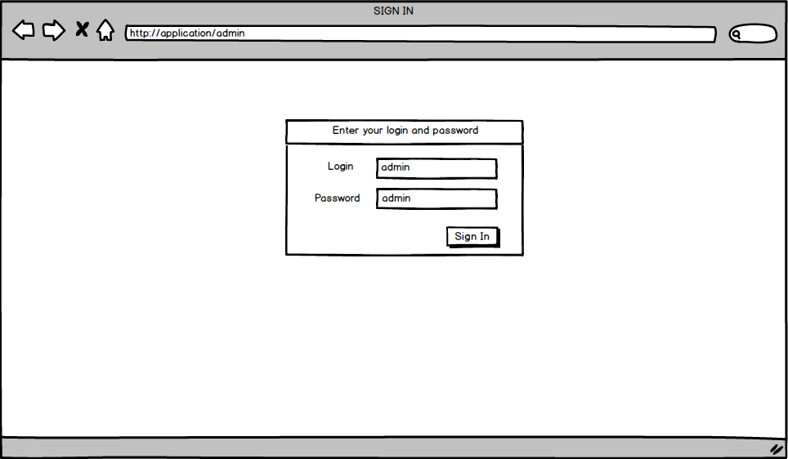

***Admin Application Login Page Table of Elements***

|  |  |  |  |  |  |  |  |
| --- | --- | --- | --- | --- | --- | --- | --- |
| **#** | **Label** | **Data Type** | **Control Type** | **Rule** | **Mandatory/Optional** | **Default Value /State** | **Description** |
| **1** | **Login** | String | Input | BRALP001  BRALP003  BRALP005 | M | Empty/ Enabled | Valid login to access Admin Application is entered into this field.  Login is case-sensitive. |
| **2** | **Password** | String | Input | BRALP002  BRALP004  BRALP005 | M | Empty/ Enabled | Valid password to access Admin Application is entered into this field.  Password is case-sensitive. |
| **3** | **Sign In** |  | Button | BRALP006 |  | Enabled | When **Sign In** is clicked, User is navigated to **Customers - Search screen** |

***Admin Application Login Page Business Rules***

|  |  |  |
| --- | --- | --- |
| **Business rule** | **Action** | **Description** |
| BRALP001 |  | We assume that access to Admin Application is granted only for a user with login **admin** |
| BRALP002 |  | We assume that access to Admin Application is granted only for a user with password **admin** |
| BRALP003 | User does not enter login and clicks **Sign In** | System detects that login is empty and displays error message “Empty login is not allowed.” |
| BRALP004 | User enters login and does not enter password and clicks **Sign In** | System detects that password is empty and displays error message “Empty password is not allowed.” |
| BRALP005 | User enters incorrect login or password and clicks **Sign In** | System detects that login and password do not match and displays error message "Access denied." |
| BRALP006 | User enters correct login and password and clicks **Sign In** | **Customers - Search screen** is displayed. |

### 1.2. Customers - Search screen (default view)

After **admin** user is logged into Admin Application, he is navigated to **Customers - Search** screen.

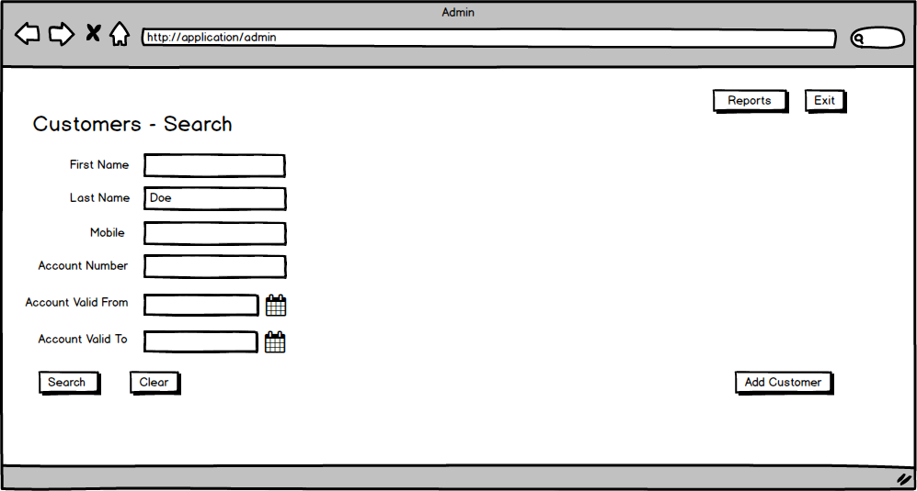

***Admin Application Customer Search Page Table of Elements***

|  |  |  |  |  |  |  |
| --- | --- | --- | --- | --- | --- | --- |
| **#** | **Label** | **Data Type** | **Control Type** | **Rule** | **Default Value/State** | **Description** |
| **1** | **Exit** |  | Button |  | Enabeled | When User clicks Exit button ih is logged out and navigated to the Login Page |
| **2** | **Reports** |  | Button |  | Enabeled | When User clicks Reports button, he is navigated to Reports Page. |
| **3** | **Customer - Search** |  | Label |  |  | Label is shown in the top left corner of the screen. |
| **4** | **First Name** | String | Input |  | Empty/  Enabled | Customer first name. |
| **5** | **Last Name** | String | Input |  | Empty/  Enabled | Customer last name. |
| **6** | **Mobile** | String | Input |  | Empty/  Enabled | Customer mobile phone number.  Contains 12 digits. |
| **7** | **Account Number** | Integer | Input |  | Empty/  Enabled | Customer account number. Contains 14 digits. |
| **8** | **Account Valid From** | Date | Date Chooser |  | Empty/  Enabled | Date from which account is valid.  Date is selected from the calendar or entered manually and is displayed in format MM/DD/YYYY. |
| **9** | **Account Valid To** | Date | Date Chooser |  | Empty/  Enabled | Date to which account is valid.  Date is selected from the calendar r or entered manually and is displayed in format MM/DD/YYYY. |
| **10** | **Search** |  | Button | BRACS001  BRACS002  BRACS003 | Enabled | When **Search** is clicked, the search for customers on the given parameters is performed. |
| **11** | **Clear** |  | Button | BRACS004 | Enabled | When **Clear** is clicked, all populated fields and search results are cleared. |
| **12** | **Add Customer** |  | Button |  | Enabled | When **Add Customer** is clicked, User is navigated to **Add Customer** screen. |

***Admin Application Customer Search Page Business Rules***

|  |  |  |
| --- | --- | --- |
| **Business rule** | **Action** | **Description** |
| BRACS001 | User is intended to find some customer, populates one, several or all search parameters and clicks **Search** | Customers having corresponding parameters are found and displayed in Customers Search Results table.  Search is performed by partial match.  Search is case-insensitive.  Customers Search Results table is displayed only if at least one customer is found. |
| BRACS002 | User enters nonexistent customer parameters and clicks **Search** | System cannot find a customer by requested search parameters and displays error message “No customers found.” |
| BRACS003 | User doesn't populate any parameters and clicks **Search** | System detects lack of parameters and displays error message “Please specify search parameters.” |
| BRACS004 | User is intended to repeat the search and clicks **Clear** | All populated fields and search results are cleared, **Customer - Search** screen is displayed in its defaulted view.  Clearing the search criteria is optional. An alternative is to update the previous search criteria. |

### 1.3. Customers - Search screen (with search results)

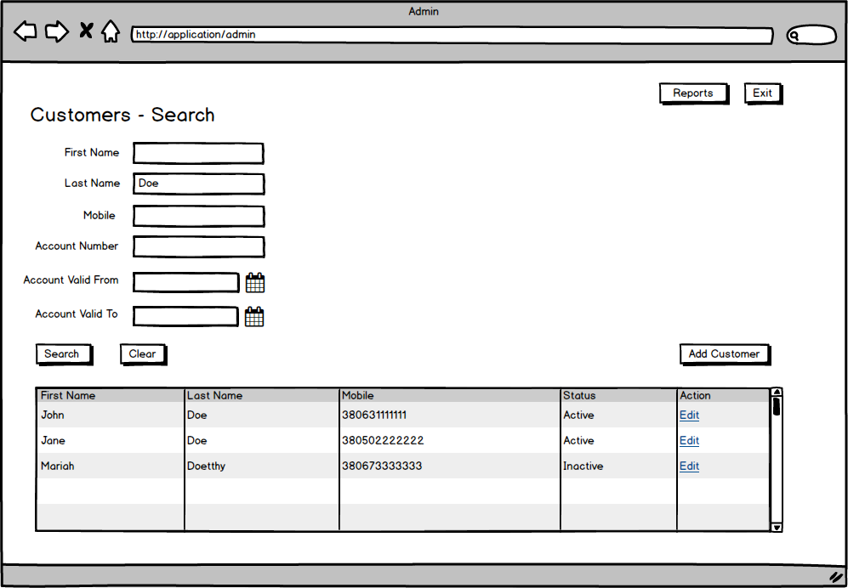

***Admin Application Customers Search Results Table of Elements (at least one customer is found)***

|  |  |  |  |  |  |  |
| --- | --- | --- | --- | --- | --- | --- |
| **##** | **Label** | **Data Type** | **Control Type** | **Rule** | **Default Value/ State** | **Description** |
| **1** | **Customer Search Results** | Multiple | Table |  |  | * Displays matching search results. * Columns width should be adjusted proportionally to size of browser’s window * Table has scrollbar * Sorting is made by Last Name in alphabetical order |
| **2** | **First Name** | String |  | BRACSR001 |  | First name of customer found by match.  No action by clicking. |
| **3** | **Last Name** | String |  | BRACSR001 |  | Last name of customer found by match.  No action by clicking. |
| **4** | **Mobile** | String |  |  |  | Mobile phone number of customer found by match.  No action by clicking. |
| **5** | **Status** | String |  |  |  | If customer has at least one active (not expired) account the status is "Active", else - the status is "Inactive". |
| **6** | **Action** |  | Hyperlink | BRACSR002 | Edit/  Enabled | Hyperlink to edit customer information leads to **Edit Customer screen**. |

***Admin Application Customers Search Results Business Rules***

|  |  |  |
| --- | --- | --- |
| **Business rule** | **Action** | **Description** |
| BRACSR001 | User searches for a long first name/last name | If text is too long (doesn’t fit in one row) its ending should be cut (e.g. “*a very long text has ending c…*”). Full summary text should always be displayed in hover-over hint (when mouse is placed over the text). |
| BRACSR002 | User clicks **Edit** next to desired customer. | User is navigated to Customer - Edit screen. |

### 1.4. Add Customer screen

After user clicks **Add Customer** at **Customers - Search** screen he is navigated to **Add Customer** screen.

**Add Customer** screen contains 5 sections: General Information, Contact Details, Customer Specific Information, Accounts and Cards which can be expanded and collapsed. Next mockups demonstrate every section in expanded view.

**General Information on**  **Add Customer screen**

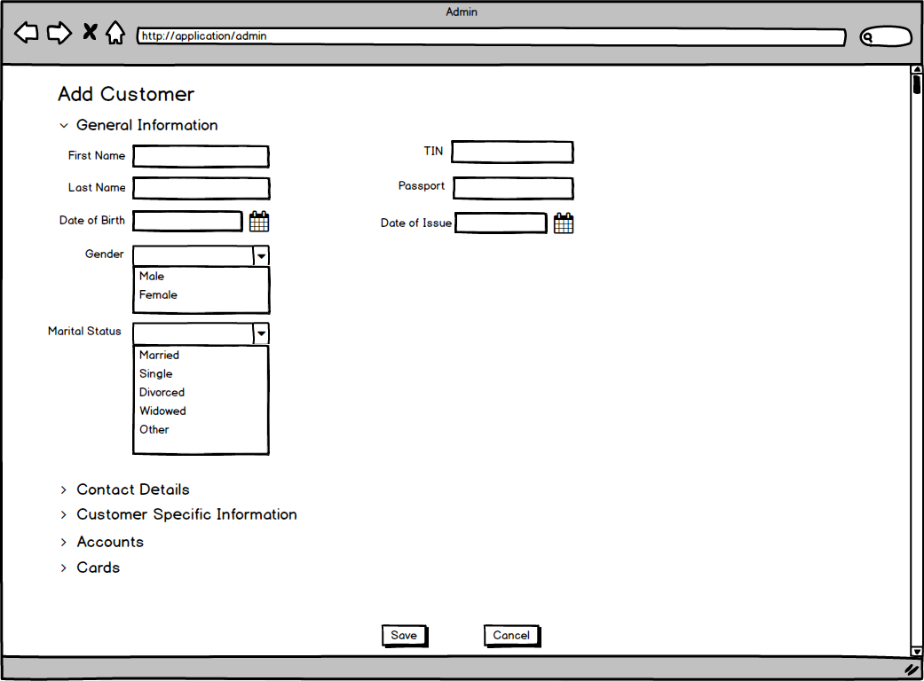

**Contact Details with the same Mailing Address as Registration Address on Add Customer screen**

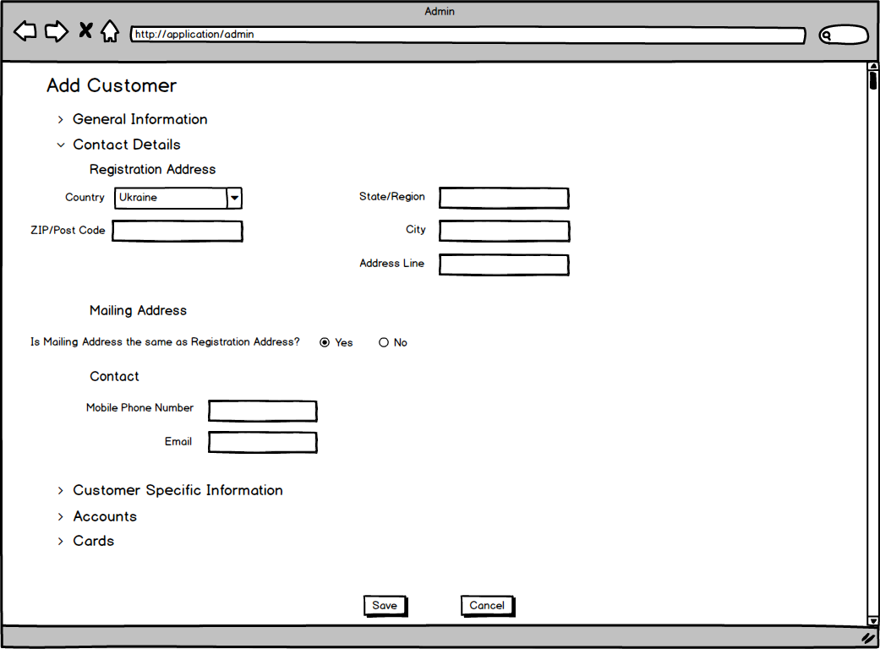

**Contact Details with the Mailing Address which is different from Registration Address on Add Customer screen**

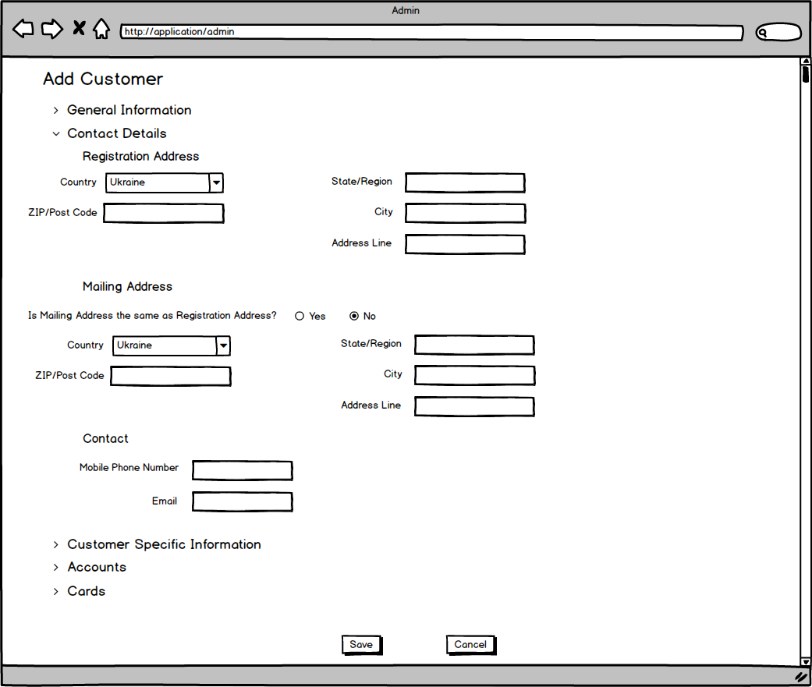

**Customer Specific Information on Add Customer screen**

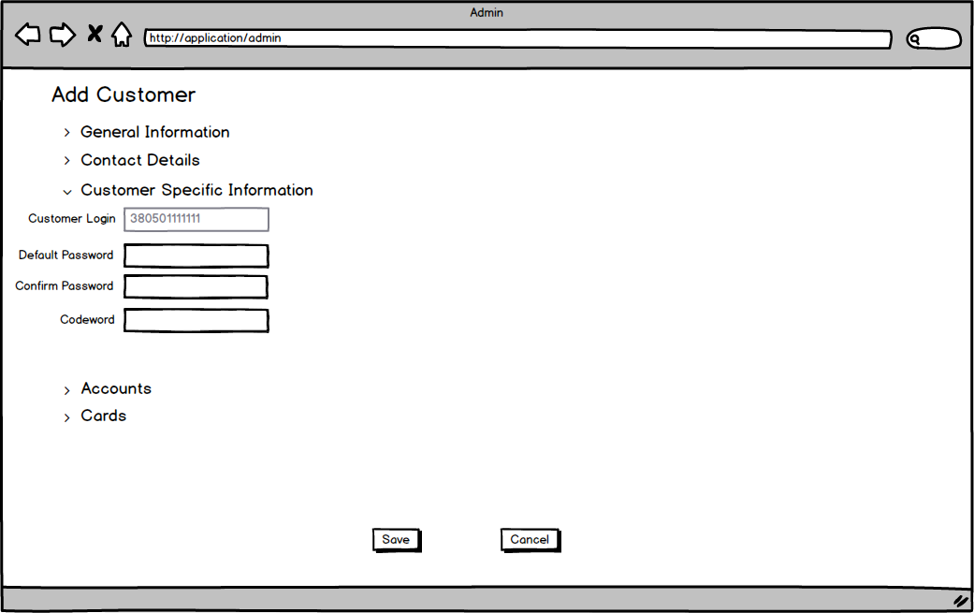

**Accounts (no account added) on Add Customer screen**

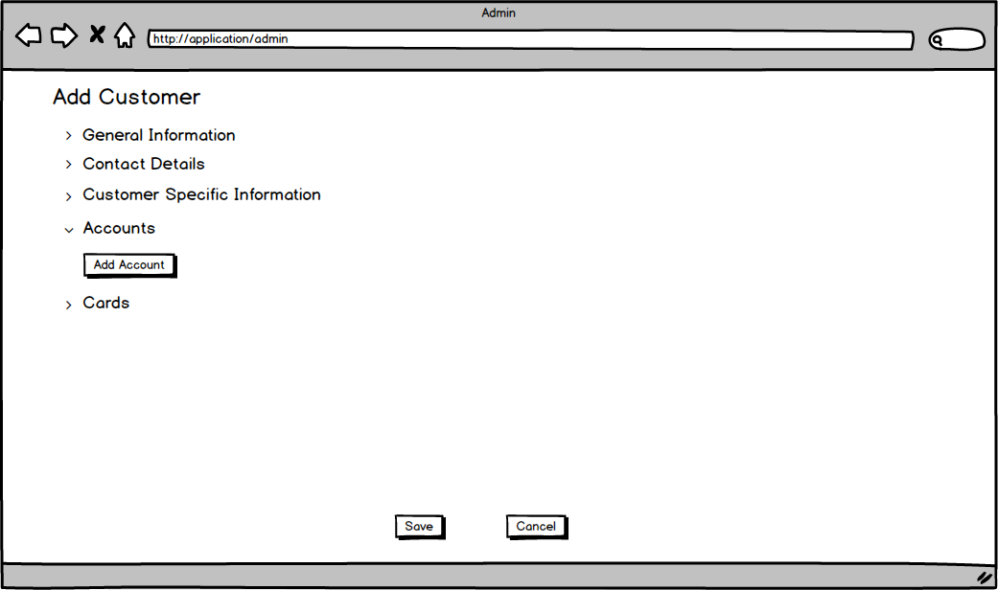

**Accounts (at least one account added) on Add Customer screen**

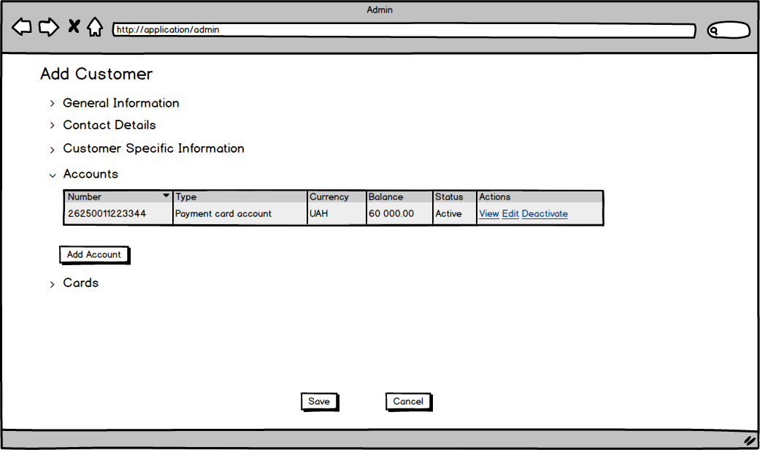

**Cards (no cards added) on Add Customer screen** 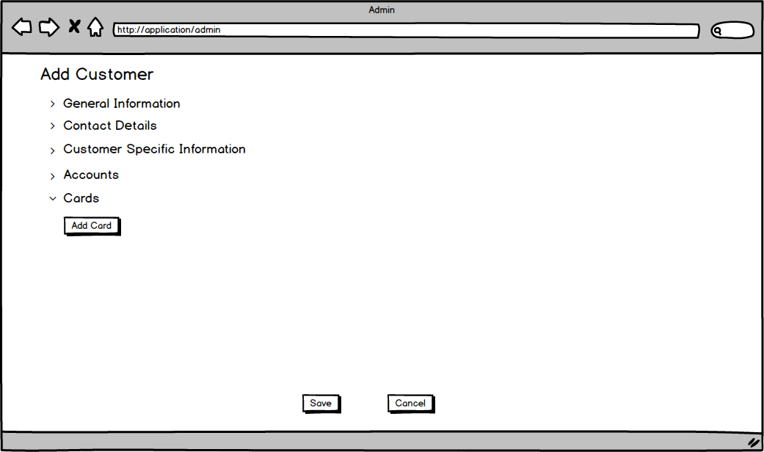

**Cards (at least one card added) on Add Customer screen**

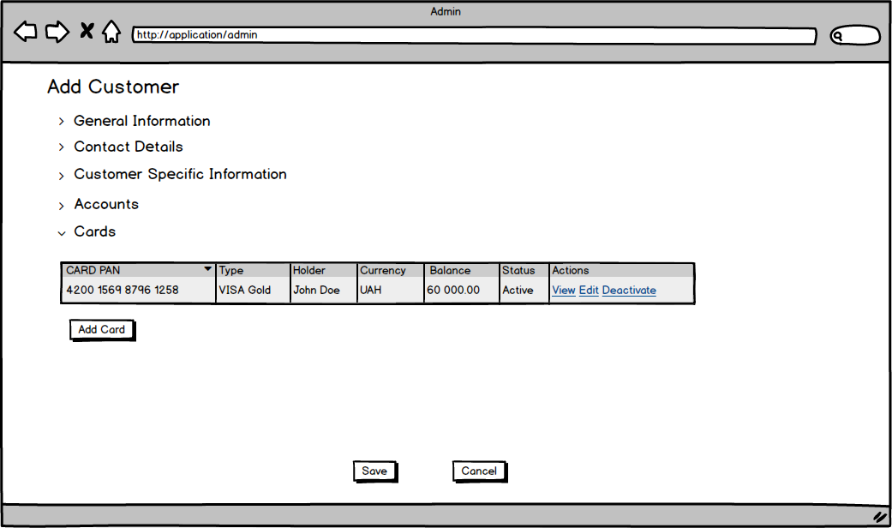

***Admin Application Add Customer Table of Elements***

|  |  |  |  |  |  |  |  |
| --- | --- | --- | --- | --- | --- | --- | --- |
| **№** | **Label** | **Data Type** | **Control Type** | **Rule** | **Mandatory/Optional** | **Default Value/ State** | **Description** |
| **1** | **Add Customer** |  | Label |  |  |  | Label is shown in the top left corner of the screen in Add Customer mode. |
| **2** | **Expand/**  **Collapse arrow** |  | Icon | BRAAC001  BRAAC002 |  | Points down/  Enabled | Arrow indicates that it is possible to open and close the section.  The arrow points right when the section is collapsed and down when expanded.  By default **General Information** is expanded, all other sections are collapsed. |
| **3** | **General Information** |  | Label |  |  |  | Label is shown under **Add Customer** label |
| **4** | **First Name** | String | Input | BRAAC003  BRAAC004  BRAAC005 | M | Empty/  Enabled | Customer first name in Latin. Can also contain spaces and dashes in case of a compound first name.  Maximum length is 255 symbols. |
| **5** | **Last Name** | String | Input | BRAAC006  BRAAC007  BRAAC008 | M | Empty/  Enabled | Customer last name in Latin.  Can also contain spaces and dashes in case of a compound last name.  Maximum length is 255 symbols. |
| **6** | **Date Of Birth** | Date | Date Chooser | BRAAC009  BRAAC010  BRAAC011  BRAAC012 | M | Empty/  Enabled | Customer date of birth in format MM/DD/YYYY.  Non-adult person cannot be registered as customer as well as an older adult.  Thus, the boundaries for Date of Birth are not more than 120 years before the current date and not less than 18 years before the current date. |
| **7** | **Gender** | String | Drop-down list | BRAAC013 | M | Empty/  Enabled | Customer gender.  Available values:   * Male * Female |
| **8** | **Marital Status** | String | Drop-down list |  | O | Empty/  Enabled | Customer marital status.  Available values:   * Married * Single * Divorсed * Widowed * Other |
| **9** | **TIN** | String | Input | BRAAC014  BRAAC015  BRAAC016 | M | Empty/  Enabled | Customer TIN.  Consists of 10 digits.  Must be unique. |
| **10** | **Passport** | String | Input | BRAAC017  BRAAC018  BRAAC054 | M | Empty/  Enabled | Customer passport number..  Consists of 2 Latin letters and 6 digits. |
| **11** | **Date Of Issue** | Date | Date Chooser | BRAAC019  BRAAC020  BRAAC021  BRAAC022 | M | Empty/  Enabled | Date of issue of customer passport in format MM/DD/YYYY.  Cannot be after the current date, and cannot be more than 120 years before the current date. |
| **12** | **Contact Details** |  | Label |  |  |  | Label is shown under **General Information** section on **Add Customer** screen |
| **13** | **Registration Address** |  | Label |  |  |  | Label is shown under **Contact Details** label |
| **14** | **Country** | String | Drop-down list | BRAAC023 | M | Ukraine/  Enabled | Country of customer registration.  Contains the list of all countries of the world. |
| **15** | **ZIP/Post Code** | String | Input | BRAAC024  BRAAC025 | M | Empty/  Enabled | Post Code of customer registration.  Consists of 5 digits. |
| **16** | **State/Region** | String | Input | BRAAC026  BRAAC027  BRAAC028 | M | Empty/  Enabled | State/Region of customer registration.  Could consist of Latin letters, numbers, spaces and special symbols.  Maximum length is 255 symbols. |
| **17** | **City** | String | Input | BRAAC029  BRAAC030  BRAAC031 | M | Empty/  Enabled | City of customer registration.  Could consist of Latin letters, numbers, spaces and special symbols.  Maximum length is 255 symbols. |
| **18** | **Address Line** | String | Input | BRAAC032  BRAAC033  BRAAC034 | M | Empty/  Enabled | Street, house, apartment of customer registration.  Could consist of Latin letters, numbers, spaces and special symbols.  Maximum length is 255 symbols. |
| **19** | **Mailing Address** |  | Label |  |  |  | **Mailing Address** is displayed below **Registration Address** section |
| **20** | **Is Mailing Address the same as Registration Address?** | Boolean | Radio button | BRAAC035  BRAAC036  BRAAC037 | M | Yes/  Enabled | Radio button indicating the need for adding Mailing Address.  Available options:   * Yes * No |
| **21** | **Country** | String | Drop-down list | BRAAC023 | M if displayed | Ukraine/  Enabled | Country of customer mailing address.  Contains the list of all countries of the world. |
| **22** | **ZIP/Post Code** | String | Input | BRAAC024  BRAAC025 | M if displayed | Empty/  Enabled | Post Code of customer mailing address.  Consists of 5 digits. |
| **23** | **State/Region** | String | Input | BRAAC026  BRAAC027  BRAAC028 | M if displayed | Empty/  Enabled | State/Region of customer mailing address.  Could consist of Latin letters, numbers, spaces and special symbols.  Maximum length is 255 symbols. |
| **24** | **City** | String | Input | BRAAC029  BRAAC030  BRAAC031 | M if displayed | Empty/  Enabled | City of customer mailing address..  Could consist of Latin letters, numbers, spaces and special symbols.  Maximum length is 255 symbols. |
| **25** | **Address Line** | String | Input | BRAAC032  BRAAC033  BRAAC034 | M if displayed | Empty/  Enabled | Street, house, apartment of customer mailing address.  Could consist of Latin letters, numbers, spaces and special symbols.  Maximum length is 255 symbols. |
| **26** | **Contact** |  | Label |  |  |  | **Contact** is displayed below **Mailing Address** section |
| **27** | **Mobile Phone Number** | String | Input | BRAAC038  BRAAC039  BRAAC040 | M | Empty/  Enabled | Customer mobile phone number.  Consists of 12 digits starting from **380**.  Three digits following 38 represent a valid code of Ukrainian mobile carrier.  Must be unique. |
| **28** | **Email** | String | Input | BRAAC041 | O | Empty/  Enabled | Customer email.  Consists of *local-part@domain.*  Valid input is /^[a-zA-Z0-9.!#$%&’*+/=?^_`{|}~-]+@[a-zA-Z0-9-]+(?:\.[a-zA-Z0-9-]+)*$/ |
| **29** | **Customer Specific Information** |  | Label |  |  |  | **Customer Specific Information** is displayed below **Contact Details** section |
| **30** | **Customer Login** | String | Input | BRAAC042 | M | Mobile Phone Number/  Disabled | Mobile Phone Number specified in **Contact** section is used as Customer Login in Customer Application. |
| **31** | **Default Password** | String | Input | BRAAC043  BRAAC044  BRAAC045 | M | Empty/  Enabled | Password which is assigned by admin to customer for the first log into Customer Application.  Must be at least 8 characters long.  Must contain members of at least three out of four groups:   * UPPER case * lower case * numbers * specific special symbols. |
| **32** | **Confirm Password** | String | Input | BRAAC046  BRAAC047 | M | Empty/  Enabled | Password entered in **Confirm Password** field must match the password entered in **Default Password** field. |
| **33** | **Codeword** | String | Input | BRAAC052  BRAAC053 | O | Last Name/  Enabled | Customer Last Name is used as Codeword by default.  Can consist of maximum 255 symbols in Latin.  Can also contain spaces and dashes in case of a compound last name.  Might be changed or not used if needed. |
| **34** | **Accounts** |  | Label |  |  |  | **Accounts** is displayed below **Customer Specific Information** section |
| **35** | **Add Account** |  | Button | BRAAC048 |  | Enabled | When **Add Account** is clicked, user is navigated to **Add Account** screen. |
| **36** | **Accounts** | Multiple | Table |  | O |  | Displays all customer accounts.  Visible if at least one account is added.  Contains next columns:   * Number * Type * Currency * Balance * Status * Actions (View - enabled, Edit - enabled for active accounts, Deactivate - enabled for active accounts)   Columns width should be adjusted proportionally to size of browser’s window. |
| **37** | **Cards** |  | Label |  |  |  | **Cards** is displayed below **Accounts** section |
| **38** | **Add Card** |  | Button | BRAAC049  BRAAC057 |  | Disabled | When **Add Card** is clicked, user is navigated to **Add Card** screen. Enabled only for Customers with at least one active Payment Card account or Loan Account. |
| **39** | **Cards** | Multiple | Table |  | O |  | Displays all customer cards.  Visible if at least one account is added  Contains next columns:   * CARD PAN * Type * Holder * Currency * Balance * Status * Actions   Columns width should be adjusted proportionally to size of browser’s window. |
| **40** | **Save** |  | Button | BRAAC050 |  | Enabled | When **Save** is clicked, User is navigated back to **Customers - Search screen** |
| **41** | **Cancel** |  | Button | BRAAC051 |  | Enabled | When **Cancel** is clicked, User is navigated back to**Customers - Search screen** |

***Admin Application Add Customer Business Rules***

|  |  |  |
| --- | --- | --- |
| **Business rule** | **Action** | **Description** |
| BRAAC001 | User clicks on the arrow when it points down. | Arrow changes its direction and points right, corresponding section is collapsed. |
| BRAAC002 | User clicks on the arrow when it points right. | Arrow changes its direction and points down, corresponding section is expanded.. |
| BRAAC003 | User does not enter **First Name** and clicks **Save** | System detects that **First Name** is empty and displays error message “First Name is mandatory.” |
| BRAAC004 | User enters other symbols than Latin letters, spaces and dashes into **First Name** and clicks **Save** | System detects that **First Name** contains other symbols than Latin letters, spaces and dashes and displays error message “First Name must be of 255 symbols or less and can only consist of Latin letters, spaces and/or dashes.” |
| BRAAC005 | User enters more than 255 symbols into **First Name** and clicks **Save** | System detects that **First Name** contains more than 255 symbols and displays error message “First Name must be of 255 symbols or less and can only consist of Latin letters, spaces and/or dashes.” |
| BRAAC006 | User does not enter **Last Name** and clicks **Save** | System detects that **Last Name** is empty and displays error message “Last Name is mandatory.” |
| BRAAC007 | User enters other symbols than Latin letters, spaces and dashes into **Last Name** and clicks **Save** | System detects that **Last Name** contains other symbols than Latin letters, spaces and dashes and displays error message “Last Name must be of 255 symbols or less and can only consist of Latin letters, spaces and/or dashes.” |
| BRAAC008 | User enters more than 255 symbols into **Last Name** and clicks **Save** | System detects that **Last Name** contains more than 255 symbols and displays error message “Last Name must be of 255 symbols or less and can only consist of Latin letters, spaces and/or dashes.” |
| BRAAC009 | User does not select **Date of Birth** and clicks **Save** | System detects that **Date of Birth** is empty and displays error message “Date of Birth is mandatory.” |
| BRAAC010 | User manually enters **Date of Birth** in other format than MM/DD/YYYYand clicks **Save** | System detects that **Date of Birth** is not in MM/DD/YYYY and displays error message “Date format must be in MM/DD/YYYY.” |
| BRAAC011 | User selects **Date of Birth** which ismore than 120 years before the current date and clicks **Save** | System detects that **Date of Birth** is out of acceptable date range and displays error message “Date of Birth cannot be more than 120 years before the current date and less than 18 years before current date.” |
| BRAAC012 | User selects **Date of Birth** which is less than 18 years before the current date and clicks **Save** | System detects that **Date of Birth** is out of acceptable date range and displays error message “Date of Birth cannot be more than 120 years before the current date and less than 18 years before current date.” |
| BRAAC013 | User does not select **Gender** and clicks **Save** | System detects that **Gender** is empty and displays error message “Gender is mandatory.” |
| BRAAC014 | User does not enter **TIN** and clicks **Save** | System detects that **TIN** is empty and displays error message “TIN is mandatory.” |
| BRAAC015 | User enters **TIN** consisting not of 10 digits and clicks **Save** | System detects that **TIN** does not consist of 10 digits and displays error message “TIN must be of 10 digits.” |
| BRAAC016 | User populates **TIN** with TIN of existing customer and all other mandatory fields with the valid data and clicks **Save** | System detects that value of **TIN** is already assigned to another customer and displays error message “Customer with specified TIN already exists.”  New customer is not saved. |
| BRAAC017 | User does not enter **Passport** and clicks **Save** | System detects that **Passport** is empty and displays error message “Passport number is mandatory.” |
| BRAAC018 | User enters **Passport** consisting not of 2 Latin letters and 6 digits and clicks **Save** | System detects that **Passport** does not consist of 2 Latin letters and 6 digits and displays error message “Passport number must be 2 Latin letters and 6 digits.” |
| BRAAC019 | User does not select **Date of Issue** and clicks **Save** | System detects that **Date of Issue** is empty and displays error message “Date of Issue is mandatory.” |
| BRAAC020 | User manually enters **Date of Issue** in other format than MM/DD/YYYYand clicks **Save** | System detects that **Date of Issue** is not in MM/DD/YYYY and displays error message “Date format must be in MM/DD/YYYY.” |
| BRAAC021 | User selects **Date of Issue** which ismore than 120 years before the current date and clicks **Save** | System detects that **Date of Issue** is out of acceptable date range and displays error message “Date of Issue cannot be after the current date, and cannot be more than 120 years before the current date.” |
| BRAAC022 | User selects **Date of Issue** which is after the current date and clicks **Save** | System detects that **Date of Issue** is out of acceptable date range and displays error message “Date of Issue cannot be after the current date, and cannot be more than 120 years before the current date.” |
| BRAAC023 | User is intended to select other country of customer registration than Ukraine and clicks **Country** drop-down list. | System displays list of available countries.  20 countries are visible.  Selected country is in the top of the list of visible countries.  Drop-down list has vertical scroll to select from all countries. |
| BRAAC024 | User does not enter **ZIP/Post Code** and clicks **Save** | System detects that **ZIP/Post Code** is empty and displays error message “ZIP/Post Code is mandatory.” |
| BRAAC025 | User enters **ZIP/Post Code** consisting not of 5 digits and clicks **Save** | System detects that **ZIP/Post Code** does not consist of 5 digits and displays error message “ZIP/Post Code must be of 5 digits.” |
| BRAAC026 | User does not enter **State/Region** and clicks **Save** | System detects that **State/Region** is empty and displays error message “State/Region is mandatory.” |
| BRAAC027 | User enters other symbols than allowed symbols into **State/Region** and clicks **Save** | System detects that **State/Region** contains other symbols than Latin letters, numbers, spaces and special symbols and displays error message “State/Region must be of 255 symbols or less and can only consist of Latin letters, numbers, spaces and/or special symbols.” |
| BRAAC028 | User enters more than 255 symbols into **State/Region** and clicks **Save** | System detects that **State/Region** contains more than 255 symbols and displays error message “State/Region must be of 255 symbols or less and can only consist of Latin letters, numbers, spaces and/or special symbols.” |
| BRAAC029 | User does not enter **City** and clicks **Save** | System detects that **City** is empty and displays error message “City is mandatory.” |
| BRAAC030 | User enters other symbols than allowed symbols into **City** and clicks **Save** | System detects that **City** contains other symbols than Latin letters, numbers, spaces and special symbols and displays error message “City must be of 255 symbols or less and can only consist of Latin letters, numbers, spaces and/or special symbols.” |
| BRAAC031 | User enters more than 255 symbols into **City** and clicks **Save** | System detects that **City** contains more than 255 symbols and displays error message “City must be of 255 symbols or less and can only consist of Latin letters, numbers, spaces and/or special symbols.” |
| BRAAC032 | User does not enter **Address Line** and clicks **Save** | System detects that **Address Line** is empty and displays error message “Address Line is mandatory.” |
| BRAAC033 | User enters other symbols than allowed symbols into **Address Line** and clicks **Save** | System detects that **Address Line** contains other symbols than Latin letters, numbers, spaces and special symbols and displays error message “Address Line must be of 255 symbols or less and can only consist of Latin letters, numbers, spaces and/or special symbols.” |
| BRAAC034 | User enters more than 255 symbols into **Address Line** and clicks **Save** | System detects that **Address Line** contains more than 255 symbols and displays error message “Address Line must be of 255 symbols or less and can only consist of Latin letters, numbers, spaces and/or special symbols.” |
| BRAAC035 | User decides not to add other address as Mailing Address and keeps **Yes** radio button selected | System saves copy of Registration Address as Mailing Address. |
| BRAAC036 | User decides to add other address as Mailing Address and clicks **No** radio button | System displays **Country, ZIP/Post Code, State/Region, City, Address** **Line** fields under **Mailing Address** section. |
| BRAAC037 | User clicks **No** radio button, populates available fields and clicks **Yes** radio button. | System hides **Country, ZIP/Post Code, State/Region, City, Address** **Line** fields under **Mailing Address** section and clears all populated values.  System saves copy of Registration Address as Mailing Address. |
| BRAAC038 | User does not enter **Mobile Phone Number** and clicks **Save** | System detects that **Mobile Phone Number** is empty and displays error message “Mobile Phone Number is mandatory.” |
| BRAAC039 | User enters **Mobile Phone Number** which does not consist of 12 digits starting from 380 and clicks **Save** | System detects that **Mobile Phone Number** is entered in the wrong format and displays error message “Mobile Phone Number must be in format 380ХХХХХХХХХ.” |
| BRAAC040 | User populates **Mobile Phone Number** with Mobile Phone Number of existing customer and all other mandatory fields with the valid data and clicks **Save** | System detects that value of **Mobile Phone Number** is already assigned to another customer and displays error message “Customer with specified Mobile Phone Number already exists.”  New customer is not saved. |
| BRAAC041 | User enters **Email** which does not match defined format and clicks **Save** | System detects that **Email** is entered in the wrong format and displays error message “Email does not match defined format.” |
| BRAAC042 | User clears or changes **Mobile Phone Number** | System clears or changes **Customer Login** correspondingly. |
| BRAAC043 | User does not enter **Default Password** and clicks **Save** | System detects that **Default Password** is empty and displays error message “Default Password is mandatory.” |
| BRAAC044 | User enters **Default Password** which does not contain members of at least three out of four groups (UPPER case, lower case, numbers, specific special symbols)and clicks **Save** | System detects that **Default Password** does not match the complexity requirements and displays error message “Default Password does not match the complexity requirements. Your entry is too short, or does not contain members of at least three out of four groups (UPPER case, lower case, numbers, specific special symbols).” |
| BRAAC045 | User enters **Default Password** which is less than 8 symbols and clicks **Save** | System detects that **Default Password** does not match the complexity requirements and displays error message “Default Password does not match the complexity requirements. Your entry is too short, or does not contain members of at least three out of four groups (UPPER case, lower case, numbers, specific special symbols).” |
| BRAAC046 | User does not enter anything into **Confirm Password** and clicks **Save** | System detects that **Confirm Password** field is empty and displays error message “Default Password must be confirmed.” |
| BRAAC047 | User enters a password which does not match Default Password in **Confirm Password** field and clicks **Save** | System detects that value in **Confirm Password** field does not match Default Password and displays error message “Confirmation Password does not match Default Password.” |
| BRAAC048 | User clicks **Add Account** | User is navigated to **Add Account** screen**.** |
| BRAAC049 | User clicks **Add Card** | User is navigated to **Add Card** screen**.** |
| BRAAC050 | User populates all mandatory fields with the valid data and clicks **Save** | System displays **Customers - Search screen**  Added customer is saved and could be found through the search. |
| BRAAC051 | User decides to abort customer add operation and clicks **Cancel** | System displays **Customers - Search screen**  New customer is not saved. |
| BRAAC052 | User enters other symbols than Latin letters, spaces and dashes into **Codeword** and clicks **Save** | System detects that **Codeword** contains other symbols than Latin letters, spaces and dashes and displays error message “Codeword must be of 255 symbols or less and can only consist of Latin letters, spaces and/or dashes.” |
| BRAAC053 | User enters more than 255 symbols into **Codeword** and clicks **Save** | System detects that **Codeword** contains more than 255 symbols and displays error message “Codeword must be of 255 symbols or less and can only consist of Latin letters, spaces and/or dashes.” |
| BRAAC054 | User enters lowercase letters into **Passport** | System displays the entered letters as uppercase. |
| BRAAC055 | User enters spaces in any field before valid value for this field. | Systems does not display error message.  System trims spaces and interprets the value as it was entered without spaces. |
| BRAAC056 | User enters spaces in any field after valid value for this field. | Systems does not display error message.  System trims spaces and interprets the value as it was entered without spaces. |
| BRAAC057 | User has created active Payment Card Account or Loan Account within the Customer. | System enables **Add Card** button under **Cards** section. |

### 1.5. Edit Customer screen

After search by customers is performed and desired customer is found and displayed at **Customers - Search screen****,** user clicks **Edit** hyperlink next to the desired customer in **Customer Search Results table and** is navigated to **Edit Customer** screen.

**Edit Customer** screen contains the same sections and fields as**Add Customer**screen and business rules BRAAC001 - BRAAC057 are applied to all fields unless other is not specified in the tables below.

**General Information on Edit Customer screen**

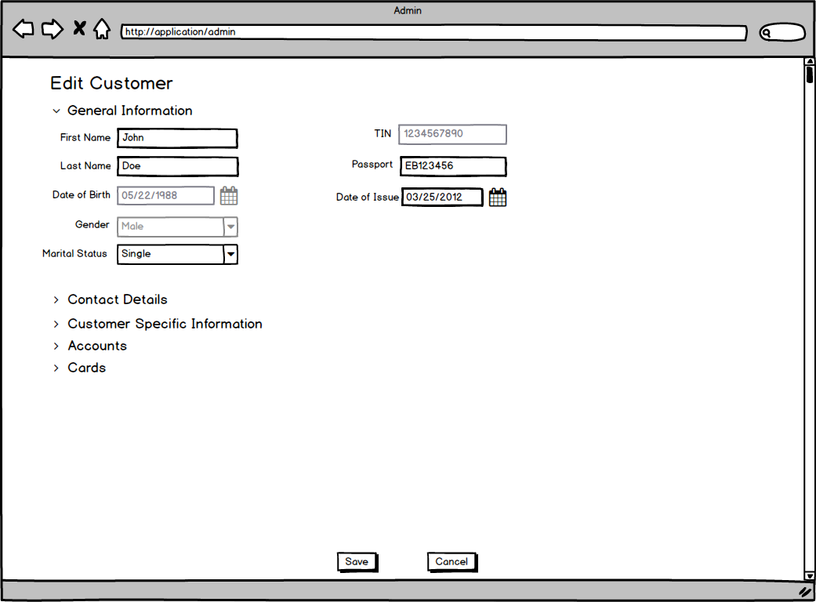

**Contact Details with the same Mailing Address as Registration Address on Edit Customer screen**

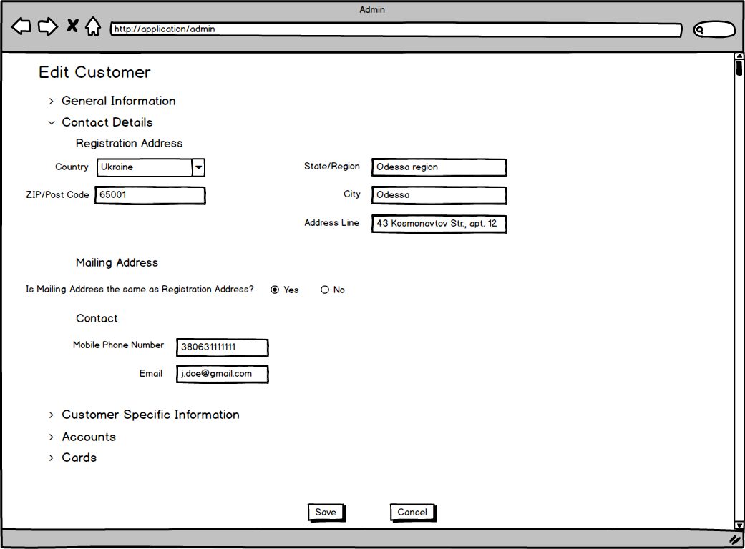

**Customer Specific Information on Edit Customer screen**

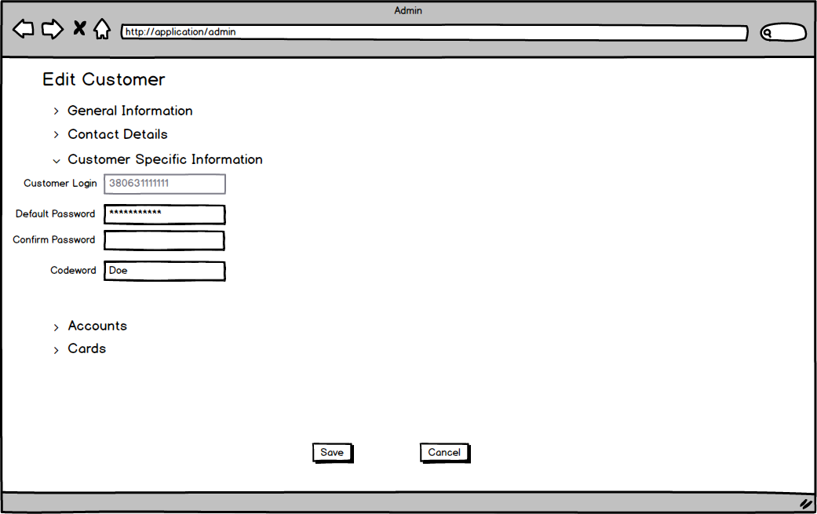

***Admin Application Edit Customer Table of Elements***

|  |  |  |  |  |  |  |  |
| --- | --- | --- | --- | --- | --- | --- | --- |
| **№** | **Label** | **Data Type** | **Control Type** | **Rule** | **Mandatory/Optional** | **Default Value/ State** | **Description** |
| **1** | **All fields** |  |  |  |  | Prefilled with previously entered and saved data / Enabled if other is not specified below |  |
| **2** | **Date Of Birth** | Date | Date Chooser |  | M | Filled with Customer date of birth/  Disabled | Cannot be changed in Edit mode. |
| **3** | **Gender** | String | Drop-down list |  | M | Filled with Customer gender/  Disabled | Cannot be changed in Edit mode. |
| **4** | **TIN** | String | Input |  | M | Filled with Customer TIN/  Disabled | Cannot be changed in Edit mode. |
| **5** | **Default Password** | String | Input | BRAEC001 | M | Filled with customer default password in encrypted form/  Enabled | Password specified while adding a customer is stored in the encrypted form.  If default password must be updated, the field is cleared by user and new password is specified.  Business Rules BRAAC043 - BRAAC045 are applied to new password.  New password should not coincide with previous default passwords for the specific customer. |
| **6** | **Confirm Password** | String | Input | BRAEC002 | M | Empty/  Enabled | Confirmation password is cleared. If default password is updated, Business Rules BRAAC046 and BRAAC047 are applied to confirmation password. |

***Admin Application Edit Customer Business Rules***

|  |  |  |
| --- | --- | --- |
| **Business rule** | **Action** | **Description** |
| BRAEC001 | User decides to update **Default Password,** enters new password which сoincides with previous passwords and clicks **Save** | System detects that new **Default Password** сoincides with previous password and displays error message “The new password does not match the non-repeatability requirements. Your entry has matched one of the previous passwords” |
| BRAEC002 | User decides not to update **Default Password** and clicks **Save** | System detects that **Default Password** has not been updated anddoes not request confirmation password. |

### 1.6. Add Account screen

After admin user navigated to **Add Customer** / **Edit Customer**, user clicks **Add Account** under **Accounts** section on **Add Customer** / **Edit Customer** screen, and is navigated to **Add Account** screen.

**General Information on Add Account screen**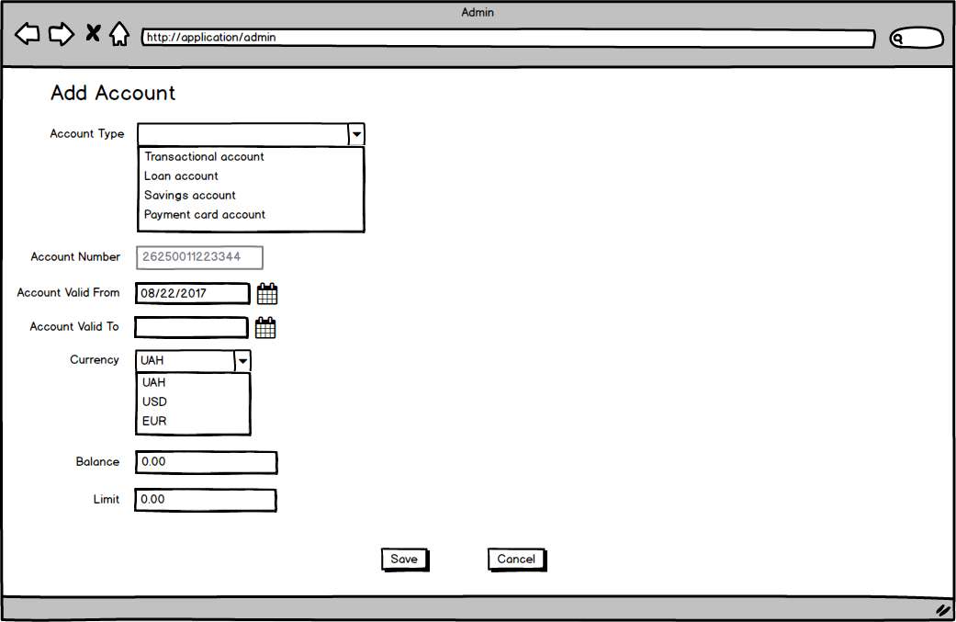

***Admin Application Add Account Table of Elements***

|  |  |  |  |  |  |  |  |
| --- | --- | --- | --- | --- | --- | --- | --- |
| **№** | **Label** | **Data Type** | **Control Type** | **Rule** | **Mandatory/Optional** | **Default Value/ State** | **Description** |
| **1** | **Add Account** |  | Label |  |  |  | Label is shown in the top left corner of the screen in Add Account mode. |
| **2** | **Account Type** | String | Drop-down list | BRAAA001 | M | Enabled | Account Type.  Available values:   * Transactional account * Loan account * Savings account * Payment card account |
| **3** | **Account Number** | Integer | Output | BRAAA002 | M | Empty/  Disabled | 14-digit unique autogenerated identifier of the Account. Autogenerated based on selected Account Type, cannot be edited. |
| **4** | **Account Valid From** | Date | Date Chooser | BRAAA003  BRAAA004  BRAAA005 | M | Prefilled with system date/Enabled | Date on which Account is getting Active in format MM/DD/YYYY. Cannot be earlier than system date. |
| **5** | **Account Valid To** | Date | Date Chooser | BRAAA006  BRAAA007  BRAAA008 | M | Empty/Enabled | Date on which Account is getting inactivated in format MM/DD/YYYY. Cannot be prior or equal to Account Valid From date. |
| **6** | **Currency** | String | Drop-down list |  | M | UAH/Enabled | Account Currency.  Available values:   * UAH * USD * EUR   Defaulted to UAH. |
| **7** | **Balance** | Double | Input | BRAAA010  BRAAA011  BRAAA012 | M | 0.00/Enabled | User account balance. **Balance** is defaulted to zero; contains two decimal places; must be a positive number or zero for newly-created Account. |
| **8** | **Limit** | Double | Input | BRAAA013  BRAAA014  BRAAA015  BRAAA016 | M | 0.00/Hidden | User Account credit limit. **Limit** is hidden for all **Account Types** except of Loan Account;  For **Account Type**=Loan Account **Limit** is shown, defaulted to zero, must be a positive number and contains two decimal places. |
| **9** | **Save** |  | Button |  |  | Enabled | When **Save** is clicked, User is navigated back to **Add/Edit Customer** screen with Accounts Section expanded and newly added Account data displayed. |
| **10** | **Cancel** |  | Button |  |  | Enabled | When **Cancel** is clicked, User is navigated back to **Add/Edit Customer** screen with Accounts Section expanded and newly added Account data not saved. |

***Admin Application Add Account Business Rules***

|  |  |  |
| --- | --- | --- |
| **Business rule** | **Action** | **Description** |
| BRAAA001 | User does not select **Account Type** and clicks **Save** | System detects that **Account Type** is empty and displays error message “Account Type is mandatory.” |
| BRAAA002 | User has selected **Account Type** | System fills in auto-generated **Account Number** based on the below rule:   * First four digits indicate Account Type: 2625 - Payment Card Account and Loan Account, 2630 - Savings Account, 2622 - Transactional Account; * Fifth digit indicate Payment Card Account or Loan Account: 0 - Savings Account, Transactional Account, 1 - Payment Card Account, 2 - Loan Account; * Digits 6 to 8 are used to identify the Bank: 111 - for all created accounts; * Digits 9 to 14 are unique autogenerated sequential number, starting from 000001. |
| BRAAA003 | User does not select **Account Valid From** and clicks **Save** | System detects that **Account Valid From** is empty and displays error message “Account Valid From is mandatory.” |
| BRAAA004 | User manually enters **Account Valid From** in other format than MM/DD/YYYYand clicks **Save** | System detects that **Account Valid From** is not in MM/DD/YYYY and displays error message “Date format must be in MM/DD/YYYY.” |
| BRAAA005 | User selects **Account Valid From** which is prior to the system date and clicks **Save** | System detects that **Account Valid From** date is prior to the system date and displays error message “Account Valid From cannot be prior to current date.” |
| BRAAA006 | User does not select **Account Valid To** and clicks **Save** | System detects that **Account Valid To** is empty and displays error message “Account Valid To is mandatory.” |
| BRAAA007 | User manually enters **Account Valid To** in other format than MM/DD/YYYYand clicks **Save** | System detects that **Account Valid To** is not in MM/DD/YYYY and displays error message “Date format must be in MM/DD/YYYY.” |
| BRAAA008 | User selects **Account Valid To** which is prior or equals to the **Account Valid From** date and clicks **Save** | System detects that **Account Valid To** date is prior or equal to the **Account Valid From** date and displays error message “Account Valid To should be after Account Valid From date.” |
| BRAAA010 | User clears default **Balance** value, does not enter new **Balance** and clicks **Save** | System detects that **Balance** is empty and displays error message “Balance is mandatory.” |
| BRAAA011 | User enters symbols other than numbers to **Balance** and clicks **Save** | System detects that **Balance** format is invalid and displays error message “Balance must be a monetary value.” |
| BRAAA012 | User enters negative **Balance** amount and clicks **Save** | System detects that **Balance** is negative and displays error message “Balance cannot be negative for new Account .” |
| BRAAA013 | User selects **Account Type** = Loan account | System shows and enables **Limit** textbox defaulted to 0.00. |
| BRAAA014 | User selects **Account Type** = Loan account, clears **Limit** and clicks **Save** | System detects that **Limit** is empty and displays error message “Limit is mandatory for Loan account.” |
| BRAAA015 | User enters symbols other than numbers to **Limit** and clicks **Save** | System detects that **Limit** format is invalid and displays error message “Limit must be a monetary value.” |
| BRAAA016 | User enters negative **Limit** amount and clicks **Save** | System detects that **Limit** is negative and displays error message “Limit cannot be negative.” |

### 1.7. View Account screen

After admin user navigated to **Add Customer** / **Edit Customer**screen, user clicks **View** hyperlink next to the desired account under **Accounts** section andis navigated to **Account** screen.

**Account** screen contains the same fields as **Add Account** screen. All fields are disabled.

**General Information on Account screen**

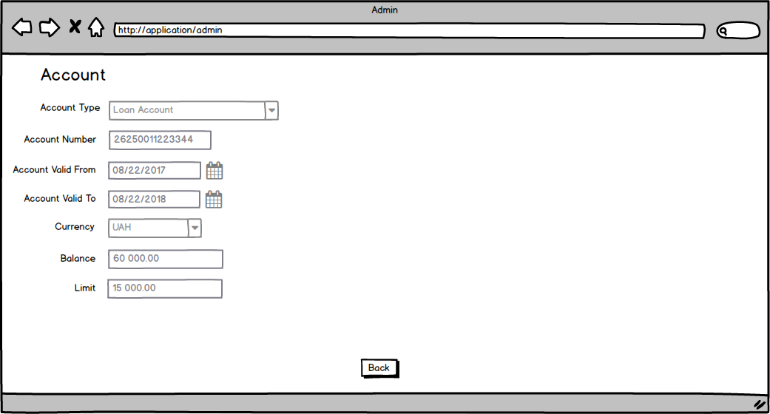

***Admin Application Account Table of Elements***

|  |  |  |  |  |  |  |  |
| --- | --- | --- | --- | --- | --- | --- | --- |
| **№** | **Label** | **Data Type** | **Control Type** | **Rule** | **Mandatory/Optional** | **Default Value/ State** | **Description** |
| **1** | **All fields** |  |  |  |  | Prefilled with previously entered and saved data / Disabled unless other is specified below |  |
| **1** | **Account** |  | Label |  |  |  | Label is shown in the top left corner of the screen in View Account mode. |
| **2** | **Account Type** | String | Drop-down list |  | M | Prefilled with Account Type selected during Account creation/Disabled | Account Type. |
| **3** | **Account Number** | Integer | Output |  | M | Filled with initial Account Number/  Disabled | 14-digit unique autogenerated identifier of the Account. |
| **4** | **Account Valid From** | Date | Date Chooser |  | M | Prefilled with Account Valid From specified during Account creation/Disabled | Date on which Account is getting Active in format MM/DD/YYYY. |
| **5** | **Account Valid To** | Date | Date Chooser |  | M | Prefilled with Account Valid To specified during Account creation/Disabled | Date on which Account is getting inactivated in format MM/DD/YYYY. |
| **6** | **Currency** | String | Drop-down list |  | M | Prefilled with Currency selected during Account creation/Disabled | Account Currency. |
| **7** | **Balance** | Double | Input |  | M | Prefilled with actual account balance/Disabled | User account balance. |
| **8** | **Limit** | Double | Input |  | M | Prefilled with actual account limit/Disabled | User Account credit limit. **Limit** is hidden for all **Account Types** except of Loan Account; |
| **9** | **Back** |  | Button |  |  | Enabled | When **Back** is clicked, User is navigated back to **Add/Edit Customer** screen with Accounts Section expanded. |

### 1.8. Edit Account screen

After admin user navigated to **Add Customer** / **Edit Customer**screen, user clicks **Edit** hyperlink next to the desired active account under **Accounts** section andis navigated to **Edit Account** screen.

**Edit Account** screen contains the same fields as **Add Account** screen and business rules BRAAA001 - BRAAA016 are applied to corresponding fields unless other is specified in the tables below.

**General Information on Edit Account screen**

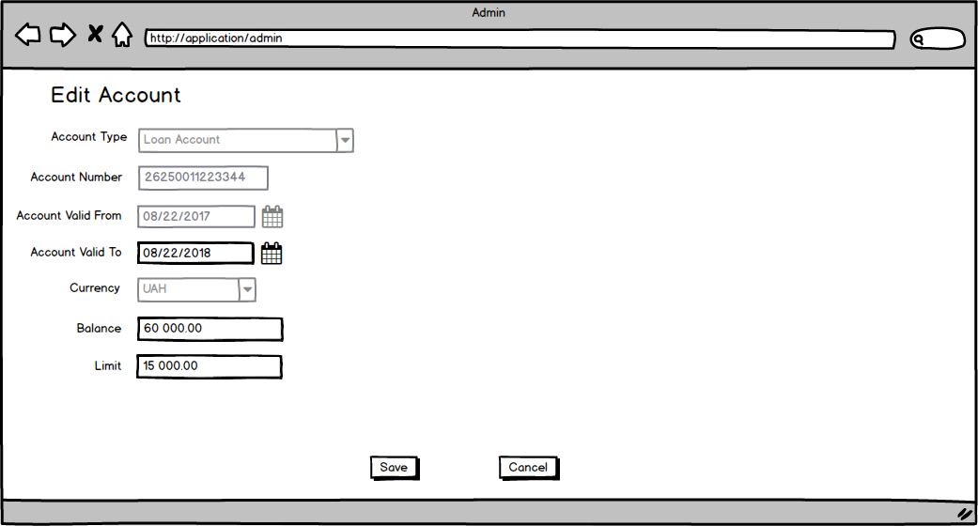

***Admin Application Edit Account Table of Elements***

|  |  |  |  |  |  |  |  |
| --- | --- | --- | --- | --- | --- | --- | --- |
| **№** | **Label** | **Data Type** | **Control Type** | **Rule** | **Mandatory/Optional** | **Default Value/ State** | **Description** |
| **1** | **All fields** |  |  |  |  | Prefilled with previously entered and saved data / Enabled if other is not specified below |  |
| **2** | **Edit Account** |  | Label |  |  |  | Label is shown in the top left corner of the screen in Edit Account mode. |
| **3** | **Account Type** | String | Drop-down list |  | M | Prefilled with Account Type selected during Account creation/Disabled | Account Type. Cannot be edited on **Edit Account** screen. |
| **4** | **Account Number** | Integer | Output |  | M | Filled with initial Account Number/  Disabled | 14-digit unique autogenerated identifier of the Account. Autogenerated based on selected Account Type, cannot be edited. |
| **5** | **Account Valid From** | Date | Date Chooser |  | M | Prefilled with Account Valid From specified during Account creation/Disabled | Date on which Account is getting Active in format MM/DD/YYYY. Cannot be edited on **Edit Account** screen. |
| **6** | **Account Valid To** | Date | Date Chooser | BRAEA001 | M | Prefilled with Account Valid To specified during Account creation/Enabled | Date on which Account is getting inactivated in format MM/DD/YYYY. Cannot be prior or equal to Account Valid From date. Cannot be prior to system Date. |
| **7** | **Currency** | String | Drop-down list |  | M | Prefilled with Currency selected during Account creation/Disabled | Account Currency. Cannot be edited on **Edit Account** screen. |
| **8** | **Balance** | Double | Input | BRAEA002  BRAEA003  (override BRAAA012) | M | Prefilled with actual account balance/Enabled | User account balance. In case of a negative balance entry, balance module value cannot exceed account **Limit**.(for accounts of Transactional account, Savings account,  Payment card account types limit is treated as zero, hence Balance cannot be negative value) |
| **9** | **Limit** | Double | Input |  | M | Prefilled with actual account limit/Enabled | User Account credit limit. **Limit** is hidden for all **Account Types** except of Loan Account; |
| **10** | **Save** |  | Button |  |  | Enabled | When **Save** is clicked, User is navigated back to **Add/Edit Customer** screen with Accounts Section expanded and edited Account data displayed. |
| **11** | **Cancel** |  | Button |  |  | Enabled | When **Cancel** is clicked, User is navigated back to **Add/Edit Customer** screen with Accounts Section expanded and Account data displayed with no changes. |

***Admin Application Edit Account Business Rules***

|  |  |  |
| --- | --- | --- |
| **Business rule** | **Action** | **Description** |
| BRAEA001 | User selects **Account Valid To** which is prior to the system date and clicks **Save** | System detects that **Account Valid To** date is prior to the system date and displays error message “Account Valid To cannot be prior to current date.” |
| BRAEA002 | User enters negative **Balance** amount for the account of *Transactional account*, *Savings account* or  *Payment card account* type and clicks **Save** | System detects that **Balance** amount is negative and displays error message “Balance cannot be negative for <Account Type>.” |
| BRAEA003 | User enters negative **Balance** amount for the account of *Loan account* type, where balance amount module exceeds specified **Limit**, and clicks **Save** | System detects that **Balance** amount module exceeds specified **Limit** and displays error message “Negative Balance amount cannot exceed Limit.” |

### 1.9. Deactivate Account pop-up window

After admin user navigated to **Add Customer** / **Edit Customer**screen, user clicks **Deactivate** hyperlink next to the desired active account under **Accounts** section and **Deactivate Account** window pops up.

**General Information on Deactivate Account pop-up window**

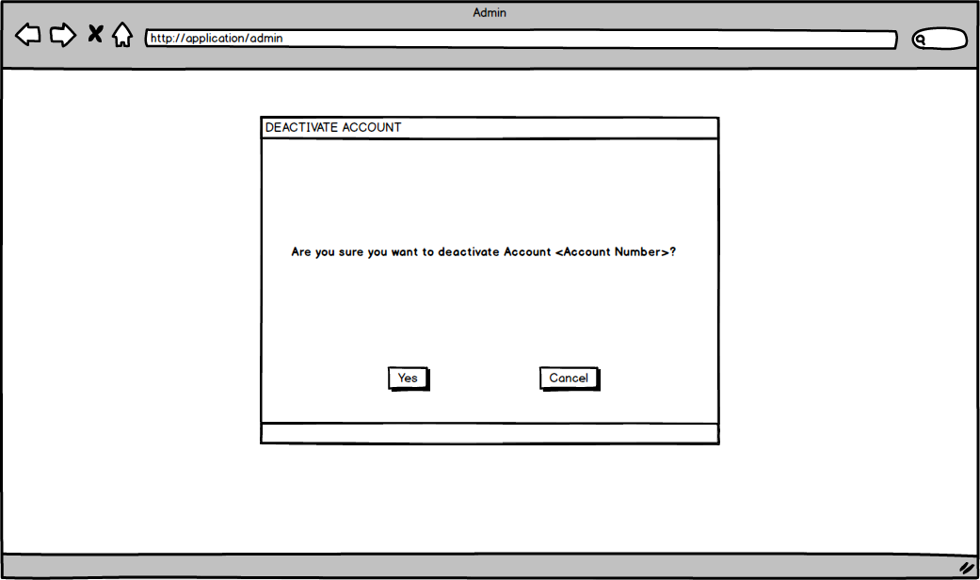

***Admin Application Deactivate Account Table of Elements***

|  |  |  |  |  |  |  |  |
| --- | --- | --- | --- | --- | --- | --- | --- |
| **№** | **Label** | **Data Type** | **Control Type** | **Rule** | **Mandatory/Optional** | **Default Value/ State** | **Description** |
| **1** | **Yes** |  | Button |  |  | Enabled | When **Yes** is clicked, User is navigated back to **Add/Edit Customer** screen with Accounts Section expanded. Account **Status** is changed to Inactive. Edit and Deactivate hyperlinks are disabled for deactivated account. **Account Valid To** date is updated to system date. Any active cards under this account are deactivated. |
| **2** | **Cancel** |  | Button |  |  | Enabled | When **Cancel** is clicked, User is navigated back to **Add/Edit Customer** screen with Accounts Section expanded and Account data displayed with no changes. |

### 1.10. Add Card screen

After admin user navigated to **Add Customer** / **Edit Customer**, user clicks **Add Card** under **Cards** section on **Add Customer** / **Edit Customer** screen for Customer with at least one active Payment Card account or Loan account, and is navigated to **Add Card** screen.

**General Information on Add Card screen**

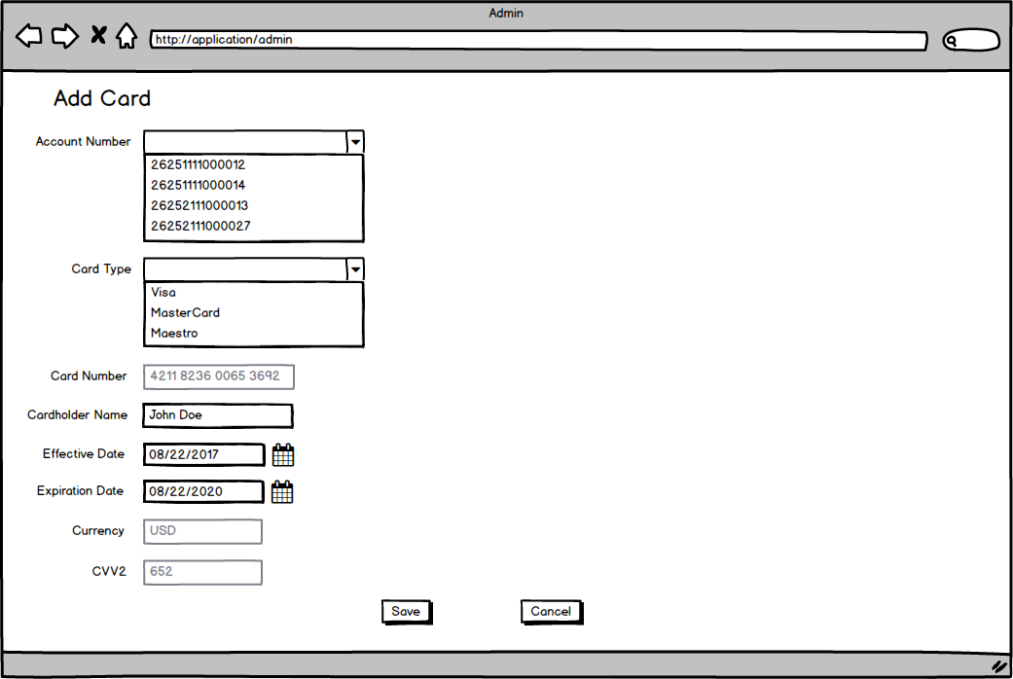

***Admin Application Add Card Table of Elements***

|  |  |  |  |  |  |  |  |
| --- | --- | --- | --- | --- | --- | --- | --- |
| **№** | **Label** | **Data Type** | **Control Type** | **Rule** | **Mandatory/Optional** | **Default Value/ State** | **Description** |
| **1** | **Add Card** |  | Label |  |  |  | Label is shown in the top left corner of the screen in Add card mode. |
| **2** | **Account Number** | Integer | Drop-down list | BRAAPC001 | M | Empty/Enabled | List of all active Payment Card and Loan accounts of the Customer. |
| **3** | **Card Type** | String | Drop-down list | BRAAPC002 | M | Empty/Enabled | Card Type.  Available values:   * Visa * MasterCard * Maestro |
| **4** | **Card Number** | Integer | Output | BRAAPC014 | M | Empty/Disabled | Unique 16-digit autogenerated Card identifier. |
| **5** | **Cardholder Name** | String | Input | BRAAPC003  BRAAPC004  BRAAPC005  BRAAPC006 | M | Filled with Customer Name/  Enabled | Cardholder Name in Latin. Can also contain spaces and dashes.  Maximum length is 511 symbols.  By default prefilled with Customer Name (First Name + Last Name) |
| **6** | **Effective Date** | Date | Date Chooser | BRAAPC007  BRAAPC008  BRAAPC009 | M | Prefilled with maximal value between system date and **Account Valid From** date of the selected Account/Enabled | Date on which Card is getting effective in format MM/DD/YYYY.  Prefilled with maximal value between system date and **Account Valid From** date of the selected Account. Editable.  Cannot be earlier than system date. Cannot be earlier than **Account Valid From** date of the selected Account. |
| **7** | **Expiration Date** | Date | Date Chooser | BRAAPC010  BRAAPC011  BRAAPC012  BRAAPC013 | M | Prefilled with minimal value between **Effective Date**+3 Years and **Account Valid To** date of the selected Account/Enabled | Date on which Card is getting expired in format MM/DD/YYYY. Cannot be earlier or equal to the **Effective Date**. Prefilled with minimal value between **Effective Date**+3 Years and **Account Valid To** date of the selected Account. |
| **8** | **Currency** | String | Output |  | M | Prefilled with currency of the selected Account/Disabled | Currency of the issued Card. Equals to Currency of the selected Account. Cannot be edited. |
| **9** | **CVV2** | Integer | Output |  | M | Autogenerated 3-digits number/Disabled | Card Verification Value. Autogenerated 3-digits number. Card Verification Value should be generated randomly. Not Editable. |
| **10** | **Save** |  | Button |  |  | Enabled | When **Save** is clicked, User is navigated back to **Add/Edit Customer** screen with Cards Section expanded and added Card data displayed. |
| **11** | **Cancel** |  | Button |  |  | Enabled | When **Cancel** is clicked, User is navigated back to **Add/Edit Customer** screen with Cards Section expanded and Cards data displayed with no changes. |

***Admin Application Add Card Business Rules***

|  |  |  |
| --- | --- | --- |
| **Business rule** | **Action** | **Description** |
| BRAAPC001 | User does not select **Account Number** and clicks **Save** | System detects that **Account Number** is empty and displays error message “Account Number is mandatory.” |
| BRAAPC002 | User does not select **Card Type** and clicks **Save** | System detects that **Card Type** is empty and displays error message “Card Type is mandatory.” |
| BRAAPC003 | User clears **Cardholder Name,** does not enter any value and clicks **Save** | System detects that **Cardholder Name** is empty and displays error message “Cardholder Name is mandatory.” |
| BRAAPC004 | User enters values other than latin letters, spaces and dashes to **Cardholder Name** and clicks **Save** | System detects that **Cardholder Name** contains other symbols than Latin letters, spaces and dashes and displays error message “Cardholder Name must be of 511 symbols or less and can only consist of Latin letters, spaces or dashes.” |
| BRAAPC005 | User enters more than 511 symbols to **Cardholder Name** and clicks **Save** | System detects that **Cardholder Name** is more than 511 symbols and displays error message “Cardholder Name must be of 511 symbols or less and can only consist of Latin letters, spaces or dashes.” |
| BRAAPC006 | User enters valid **Cardholder Name** other than prefilled Customer name, after this changes **Account Number** | System keeps entered by User **Cardholder Name** value unchanged. |
| BRAAPC007 | User clears default **Effective Date,** does not select **Effective Date** and clicks **Save** | System detects that **Effective Date** is empty and displays error message “Effective Date is mandatory.” |
| BRAAPC008 | User manually enters **Effective Date** in other format than MM/DD/YYYYand clicks **Save** | System detects that **Effective Date** is not in MM/DD/YYYY and displays error message “Date format must be in MM/DD/YYYY.” |
| BRAAPC009 | User enters **Effective Date** which is prior to the maximal value between system date and **Account Valid From** date of the selected Account and clicks **Save** | System detects that **Effective Date** is outside of allowed time period and displays error message: “Effective Date cannot be earlier than system date. Effective Date cannot be earlier than Account Valid From date of the selected Account.” |
| BRAAPC010 | User clears default **Expiration Date,** does not select **Expiration Date** and clicks **Save** | System detects that **Expiration Date** is empty and displays error message “Expiration Date is mandatory.” |
| BRAAPC011 | User manually enters **Expiration Date** in other format than MM/DD/YYYYand clicks **Save** | System detects that **Expiration Date** is not in MM/DD/YYYY and displays error message “Date format must be in MM/DD/YYYY.” |
| BRAAPC012 | User enters **Expiration Date** which is prior or equal to the **Effective Date** and clicks **Save** | System detects that **Expiration Date**  is prior or equal to the **Effective Date** and displays error message: “Expiration Date should be after the Effective Date.” |
| BRAAPC013 | User enters **Expiration Date** which is after the **Account Valid To** date of the selected Accountand clicks **Save** | System detects that **Expiration Date**  is after the **Account Valid To** date of the selected Account and displays error message: “Expiration Date cannot be earlier than system date. Expiration Date cannot be after Account Valid To date of the selected Account.” |
| BRAAPC014 | User selects **Card Type** | System populates **Card Number** autogenerated by the following rule:  First four digits identify Card Type:  4211 - Visa,  4422 - MasterCard,  4644 - Maestro;  Digits from 5 to 8 identify Bank:  0111 for all added Cards;  Digits 9 to 16 - unique sequential identifier for Card |

### 1.11. View Card screen

After admin user navigated to **Add Customer** / **Edit Customer**screen, user clicks **View** hyperlink next to the desired card under **Cards** section andis navigated to **Card** screen.

**Card** screen contains the same fields as **Add Card** screen. All fields are disabled.

**General Information on Card screen**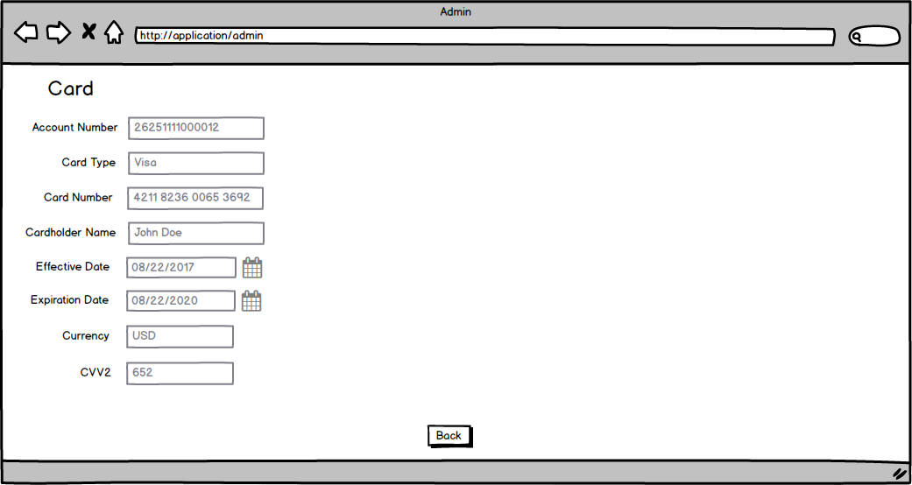

***Admin Application Card Table of Elements***

|  |  |  |  |  |  |  |  |
| --- | --- | --- | --- | --- | --- | --- | --- |
| **№** | **Label** | **Data Type** | **Control Type** | **Rule** | **Mandatory/Optional** | **Default Value/ State** | **Description** |
| **1** | **All fields** |  |  |  |  | Prefilled with previously entered and saved data / Disabled unless other is specified below |  |
| **2** | **Card** |  | Label |  |  |  | Label is shown in the top left corner of the screen in View Card mode. |
| **3** | **Back** |  | Button |  |  | Enabled | When **Back** is clicked, User is navigated back to **Add/Edit Customer** screen with Cards Section expanded. |

### 1.12. Edit Card screen

After admin user navigated to **Add Customer** / **Edit Customer**screen, user clicks **Edit** hyperlink next to the desired active card under **Cards** section andis navigated to **Edit Card** screen.

**Edit Card** screen contains the same fields as **Add Card** screen and business rules BRAAPC001 - BRAAPC013 are applied to corresponding fields unless other is specified in the tables below. User is only able to modify Expiration Date.

**General Information on Edit Card screen**

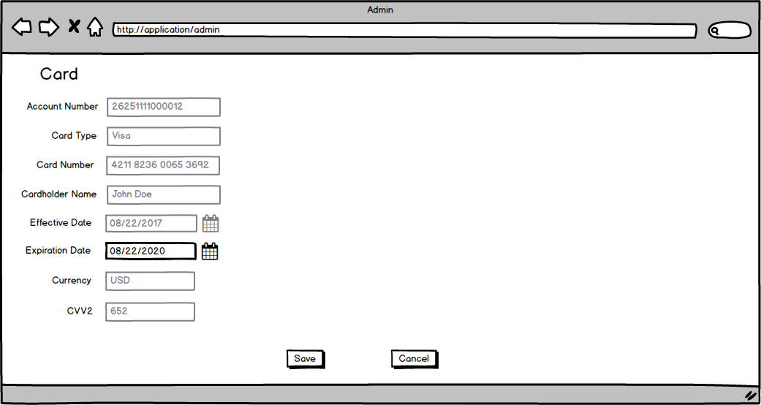

***Admin Application Edit Card Table of Elements***

|  |  |  |  |  |  |  |  |
| --- | --- | --- | --- | --- | --- | --- | --- |
| **№** | **Label** | **Data Type** | **Control Type** | **Rule** | **Mandatory/Optional** | **Default Value/ State** | **Description** |
| **1** | **All fields** |  |  |  |  | Prefilled with previously entered and saved data / Disabled if other is not specified below |  |
| **2** | **Edit Card** |  | Label |  |  |  | Label is shown in the top left corner of the screen in Edit Card mode. |
| **3** | **Expiration Date** | Date | Date Chooser |  | M | Prefilled with Expiration Dated saved during Card creation(or previous edit)/Enabled | User can update **Expiration Date** in Edit Card mode. Rules BRAAPC010-BRAAPC013 are applied. |
| **4** | **Save** |  | Button |  |  | Enabled | When **Save** is clicked, User is navigated back to **Add/Edit Customer** screen with Cards Section expanded and added Card data displayed. |
| **5** | **Cancel** |  | Button |  |  | Enabled | When **Cancel** is clicked, User is navigated back to **Add/Edit Customer** screen with Cards Section expanded and Cards data displayed with no changes. |

### 1.13. Deactivate Card pop-up window

After admin user navigated to **Add Customer** / **Edit Customer**screen, user clicks **Deactivate** hyperlink next to the desired active card under **Cards** section and **Deactivate Card** window pops up.

**General Information on Deactivate Card pop-up window**

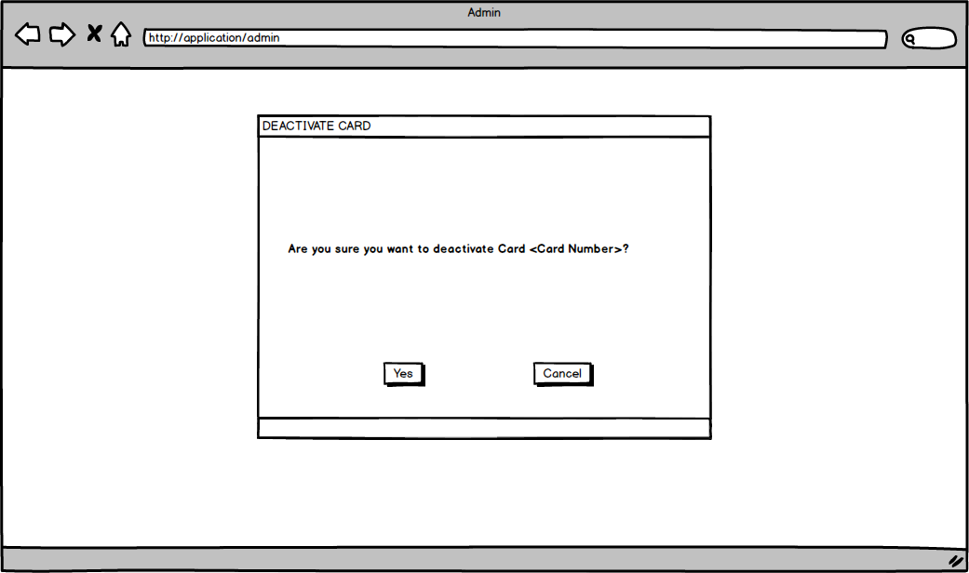

***Admin Application Deactivate Card Table of Elements***

|  |  |  |  |  |  |  |  |
| --- | --- | --- | --- | --- | --- | --- | --- |
| **№** | **Label** | **Data Type** | **Control Type** | **Rule** | **Mandatory/Optional** | **Default Value/ State** | **Description** |
| **1** | **Yes** |  | Button |  |  | Enabled | When **Yes** is clicked, User is navigated back to **Add/Edit Customer** screen with Cards Section expanded. Card **Status** is changed to Inactive. Edit and Deactivate hyperlinks are disabled for deactivated card. **Expiration** date is updated to system date. |
| **2** | **Cancel** |  | Button |  |  | Enabled | When **Cancel** is clicked, User is navigated back to **Add/Edit Customer** screen with Cards Section expanded and Cards data displayed with no changes. |

### 1.14. Reports Screen

After admin user navigated to **Customers - Search**screen, user clicks **Reports** button and is navigated to **Reports Screen**.

**General Information on Reports Screen**

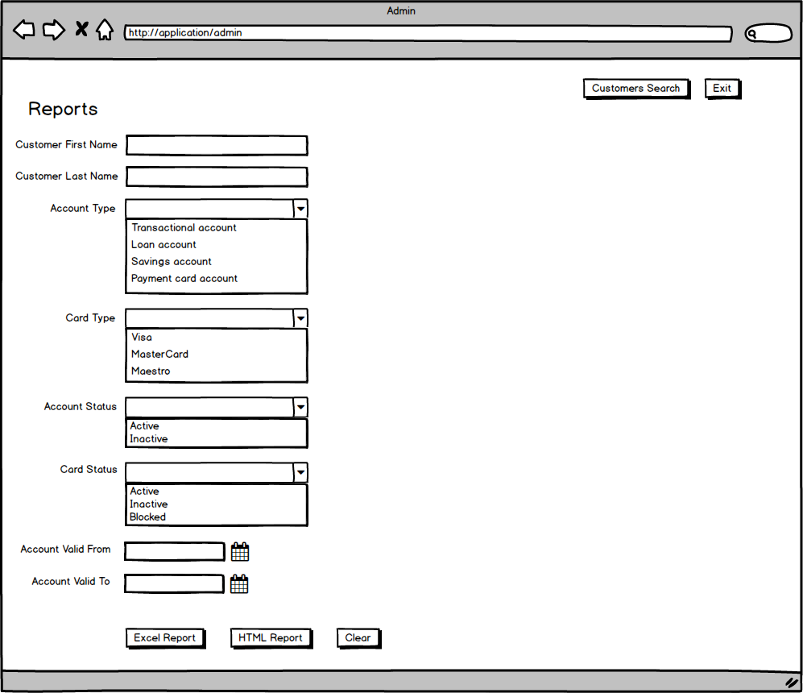

***Admin Application Reports Screen Table of Elements***

|  |  |  |  |  |  |  |  |
| --- | --- | --- | --- | --- | --- | --- | --- |
| **№** | **Label** | **Data Type** | **Control Type** | **Rule** | **Mandatory/Optional** | **Default Value/ State** | **Description** |
| **1** | **Customers Search** |  | Button |  |  | Enabled | When **Customers Search** is clicked, User is navigated back to**Customers - Search**Screen |
| **2** | **Exit** |  | Button |  |  | Enabled | When User clicks Exit button ih is logged out and navigated to the Login Page |
| **3** | **Customer First Name** | String | Input |  | O | Empty/  Enabled | Customer first name. |
| **4** | **Customer Last Name** | String | Input |  | O | Empty/  Enabled | Customer last name. |
| **5** | **Account Type** | String | Drop-down list |  | O | Empty/  Enabled | Account Type.  Available values:  ● Transactional account  ● Loan account  ● Savings account  Payment card account |
| **6** | **Card Type** | String | Drop-down list |  | O | Empty/Enabled | Card Type.  Available values:  ● Visa  ● MasterCard  ● Maestro |
| **7** | **Account Status** | String | Drop-down list |  | O | Empty/Enabled | Account Status.  Available values:  ● Active  ● Inactive  ● Blank |
| **8** | **Card Status** | String | Drop-down list |  | O | Empty/Enabled | Card Status.  Available values:  ● Active  ● Inactive  ● Blocked  ● Blank |
| **9** | **Account Valid From** | Date | Date Chooser |  | O | Empty/  Enabled | Date from which account is valid.  Date is selected from the calendar or entered manually and is displayed in format MM/DD/YYYY. |
| **10** | **Account Valid To** | Date | Date Chooser |  | O | Empty/  Enabled | Date to which account is valid.  Date is selected from the calendar or entered manually and is displayed in format MM/DD/YYYY. |
| **11** | **Excel Report** |  | Button |  |  | Enabled | When **Excel Report** is clicked, report with all the data satisfying entered parameters is downloaded in excel format. |
| **12** | **HTML Report** |  | Button |  |  | Enabled | When **HTML Report** is clicked, new browser tab with all the data satisfying entered parameters is open. |
| **13** | **Clear** |  | Button |  |  | Enabled | When **Clear** is clicked, all populated fields are cleared. |

**General Information on Reports Format**

After admin User clicked **Excel Report** or **HTML Report** button, report is generated in both cases in the below format:

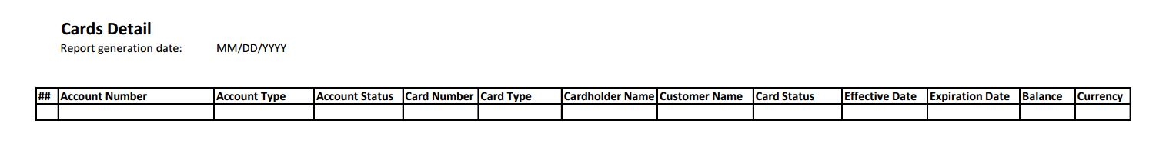

Report content should correspond to entered search parameters. Search requirements are the same as for Customers search. Report Generation Date is defaulted to current date and is in MM/DD/YYYY format. Customer Name columns is a concatenation of Customer First Name and Customer Last Name. Search results are sorted by Customer Name and Account Number.

For Customers with no accounts or no accounts satisfying entered search criteria, there should be records with empty Accounts and Cards information in the report. For Accounts with no Cards or no cards satisfying entered search criteria, there should be records with empty Cards-related cells.

If no customers found, report should be generated with no data (just a header).

## 2. Customer Application

### 2.1. Login Page

At Login Page Customer User enters his credential in order to get access to his banking information. Only authorized User should be able to see customer-related information. Access should be restricted, so logged in User can only see his own banking info, and cannot access other customers’ information.

If a User, who is not logged in to the customer application is attempting to access any page, he should be redirected to Login Page.

If a logged in Customer User attempts to access any page, related to other Customers, he should be redirected to his Main Page.

When logged in User closes application window, System logs out the User.

If System detects no user activity in the application for more than 10 minutes, System logs out the User.

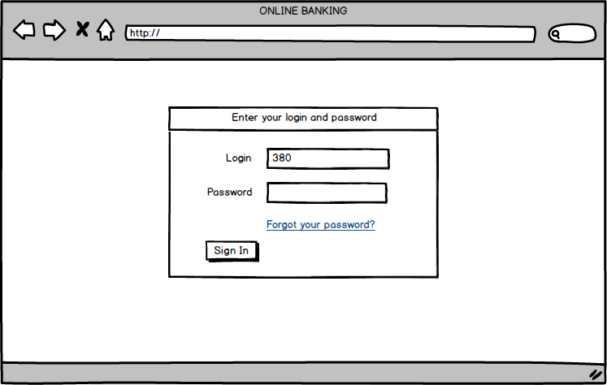

***Customer Application Login Page Table of Elements***

|  |  |  |  |  |  |  |  |
| --- | --- | --- | --- | --- | --- | --- | --- |
| **##** | **Label** | **Data Type** | **Control Type** | **Rule** | **Mandatory/Optional** | **Default Value/ State** | **Description** |
| **1** | **Login** | String | Input | BRCLP001  BRCLP002  BRCLP004 | M | 380/  Enabled | Login (mobile phone) is entered into this field.  Valid input is 12 digits starting from **380**.  Three digits following 38 represent a valid code of Ukrainian mobile carrier |
| **2** | **Password** | String | Input | BRCLP003  BRCLP004 | M | Empty/  Enabled | Password is entered into this field |
| **3** | **Forgot your password?** |  | Hyperlink |  |  | Enabled | When **Forgot your password?** is clicked, Forgot Password? pop-up window is displayed. |
| **4** | **Sign In** |  | Button |  |  | Enabled | When **Sign In** is clicked, User is navigated to Main Page. |

***Customer Application Login Page Business Rules***

|  |  |  |
| --- | --- | --- |
| **Business rule** | **Action** | **Description** |
| BRCLP001 | User enters invalid login, enters password and clicks **Sign In** | System detects that login is entered in the wrong format and displays error message “Please enter a valid phone number. Example: 380631234567.” |
| BRCLP002 | User does not enter login and clicks **Sign In** | System detects that login is empty and displays error message “Empty login is not allowed.” |
| BRCLP003 | User enters login and does not enter password and clicks **Sign In** | System detects that login is empty and displays error message “Empty password is not allowed.” |
| BRCLP004 | User enters incorrect login or password and clicks **Sign In** | System detects that login and password do not match and displays error message "We don't recognize your Login and/or Password. Please try again." |

#### 2.1.1. Forgot Password? pop-up window

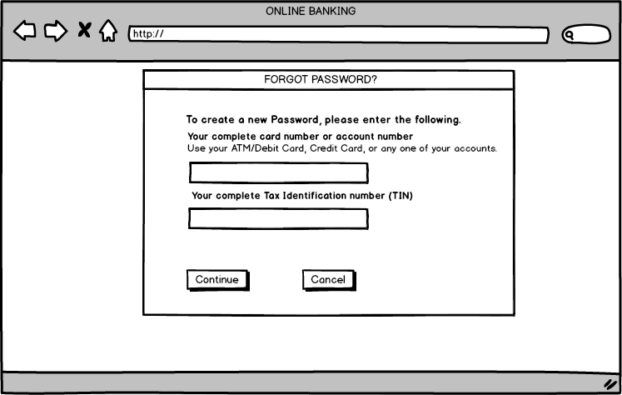

***Customer Application Forgot Password Table of Elements***

|  |  |  |  |  |  |  |  |
| --- | --- | --- | --- | --- | --- | --- | --- |
| **##** | **Label** | **Data Type** | **Control Type** | **Rule** | **Mandatory/Optional** | **Default Value/ State** | **Description** |
| **1** | **Your complete card number or account number** | Integer | Input | BRCFP001  BRCFP002  BRCFP005 | M | Empty/  Enabled | Card or account number is entered into this field.  Only numbers are allowed.  Valid card number consists of 16 digits. Valid account number consists of 14 digits. |
| **2** | **Your complete Tax Identification number (TIN)** | Integer | Input | BRCFP003  BRCFP004  BRCFP005 | M | Empty/  Enabled | Tax Identification Number is entered into this field.  Only numbers are allowed.  Valid TIN consists of 10 digits. |
| **3** | **Continue** |  | Button |  |  | Enabled | When existing combination of card/account number and TIN is entered and **Continue** is clicked, User is navigated to Change Password page. |
| **4** | **Cancel** |  | Button |  |  | Enabled | When **Cancel** is clicked, pop-up window is closed. |

***Customer Application Forgot Password Business Rules***

|  |  |  |
| --- | --- | --- |
| **Business rule** | **Action** | **Description** |
| BRCFP001 | User does not enter card or account number and clicks **Continue** | System detects that card/account number is empty and displays error message “Please enter your account number.” |
| BRCFP002 | User enters invalid card or account number and clicks **Continue** | System detects that invalid information is entered and displays error message “**We're unable to complete your request at this time.**  The information you entered does not match our records. Please verify your information.  If you have any issues please call us at 0 800 500 55 55.” |
| BRCFP003 | User does not enter TIN and clicks "Continue" button. | System detects that TIN is empty and displays error message “Please enter 10 digits of your TIN.” |
| BRCFP004 | User enters invalid TIN and clicks **Continue** | System detects that invalid information is entered and displays error message “**We're unable to complete your request at this time.**  The information you entered does not match our records. Please verify your information.  If you have any issues please call us at 0 800 500 55 55.” |
| BRCFP005 | User enters card or account number and TIN which do not match and clicks **Continue** | System detects that invalid information is entered and displays error message “**We're unable to complete your request at this time.**  The information you entered does not match our records. Please verify your information.  If you have any issues please call us at 0 800 500 55 55.” |

#### 2.1.2. Change Password page (at login)

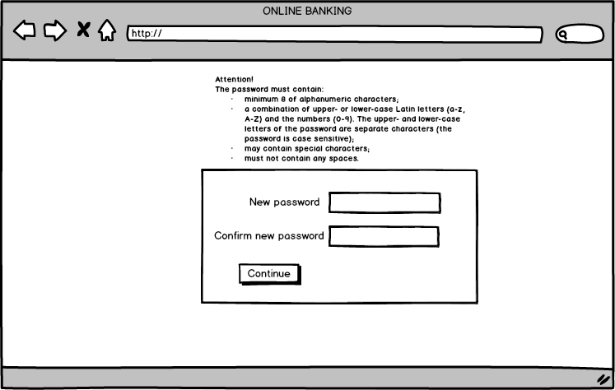

***Customer Application Change Password Table of Elements***

|  |  |  |  |  |  |  |  |
| --- | --- | --- | --- | --- | --- | --- | --- |
| **##** | **Label** | **Data Type** | **Control Type** | **Rule** | **Mandatory/Optional** | **Default Value/ State** | **Description** |
| **1** | **New password** | String | Input | BRCCP001  BRCCP002  BRCCP003  BRCCP004 | M | Empty/  Enabled | The password must contain:  - minimum 8 of alphanumeric characters;  - a combination of upper- or lower-case **Latin letters (a-z, A-Z) and the numbers (0-9)**. The upper- and lower-case letters of the password are different characters (the password is case sensitive);  - may contain special characters;  - must not contain any spaces. |
| **2** | **Confirm new password** | String | Input | BRCCP005  BRCCP006 BRCCP007 | M | Empty/  Enabled | The value of this field must be equal to the value of "New password" field. |
| **3** | **Continue** |  | Button |  |  | Enabled | When **Continue** is clicked, User is navigated to Login Page. |

***Customer Application Change Password Business Rules***

|  |  |  |
| --- | --- | --- |
| **Business rule** | **Action** | **Description** |
| BRCCP001 | User does not enter password in "New password" field and clicks **Continue** | System detects that "New password" field is empty and displays error message “Please specify new password.” |
| BRCCP002 | User enters new password which does not contain digits and clicks **Continue** | System detects that password does not meet the requirements and displays error message “New password must contain at least one digit (0-9).” |
| BRCCP003 | User enters new password which does not contain Latin letters and clicks **Continue** | System detects that password does not meet the requirements and displays error message “New password must contain at least one upper- or lower-caseLatin letter (a-z, A-Z).” |
| BRCCP004 | User enters new password which contains spaces and clicks **Continue** | System detects that password does not meet the requirements and displays error message “The password cannot comprise blanks.” |
| BRCCP005 | User does not enter password in "Confirm new password" field and clicks **Continue** | System detects that "Confirm new password" field is empty and displays error message “Please confirm your new password.” |
| BRCCP006 | User enters different passwords into "New password" and "Confirm new password" fields and clicks **Continue** | System detects that passwords mismatch and displays error message “Your new password is not coincide with confirmation.” |
| BRCCP007 | User decides to update Default Password, enters new password which сoincides with previous passwords and clicks Save | System detects that new Default Password сoincides with previous password and displays error message “The new password does not match the non-repeatability requirements. Your entry has matched one of the previous passwords” |

### 2.2. Main Page

After user is logged into his account, he sees welcome message in the header. The header part is always visible.

**Exit** is also located in the header.

Menu is located at the top of the screen, below the header. Menu is always visible.

User's cards, accounts and exchange rates are displayed in the center of the screen.

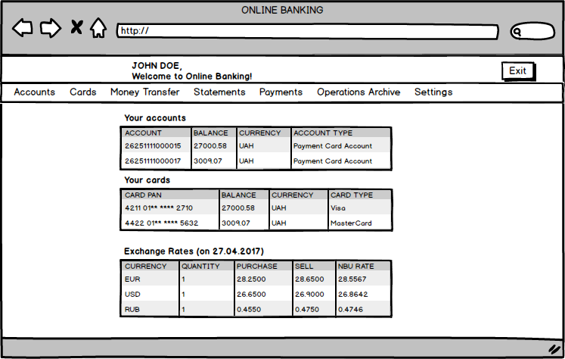

***Customer Application Main Page Table of Elements***

|  |  |  |  |  |  |  |  |
| --- | --- | --- | --- | --- | --- | --- | --- |
| **##** | **Label** | **Data Type** | **Control Type** | **Rule** | **Mandatory/Optional** | **Default Value/ State** | **Description** |
| **1** | **Exit** |  | Button |  |  | Enabled | When **Exit** is clicked, User is navigated to Login Page. |
| **2** | **Menu** |  | Group of hyperlinks in Menu header | BRCMP001 |  | Enabled | Allows navigation to any menu item. |
| **3** | **Welcome message** |  | Label |  |  |  | Consists of user's first name and last name and the phrase "Welcome to Online Banking!" |
| **4** | **Your accounts** | Multiple | Table | BRCMP002 |  |  | * Displays all user's active accounts * Columns width should be adjusted proportionally to size of browser’s window * Column rows are clickable |
| **5** | **Your cards** | Multiple | Table | BRCMP003 |  |  | * Displays all user's active cards * Columns width should be adjusted proportionally to size of browser’s window * Column rows are clickable |
| **6** | **Exchange rates** | Multiple | Table | BRCMP004 |  |  | * Displays exchange rates for current date * Columns width should be adjusted proportionally to size of browser’s window * Column rows are not clickable |

***Customer Application Main Page Business Rules***

|  |  |  |
| --- | --- | --- |
| **Business rule** | **Action** | **Description** |
| BRCMP001 | User clicks any menu item e.g. **Accounts** | User is navigated to corresponding screen e.g. "Accounts". Selected menu item is highlighted. |
| BRCMP002 | User clicks any row in **Your accounts** table | User is navigated to "Accounts" screen. |
| BRCMP003 | User clicks any row in **Your cards** table | User is navigated to "Cards" screen. |
| BRCMP004 | User navigates to **Main Page** | System displays current date in Exchange Rates label |

### 2.3. Accounts Page

After customer user navigated to **Main Page** user clicks **Accounts** in Menu section, and is navigated to **Accounts** screen. User can also navigate to **Accounts** screen by clicking any account row in **Your accounts** table on **Main Page** (see BRCMP002).

User sees page title in the header. The header part is always visible.

Exit and Main Page buttons also located in the header.

Menu is located at the top of the screen, below the header. Menu is always visible.

**General Information on Accounts screen**

**Accounts screen - Customer has no Active Accounts**

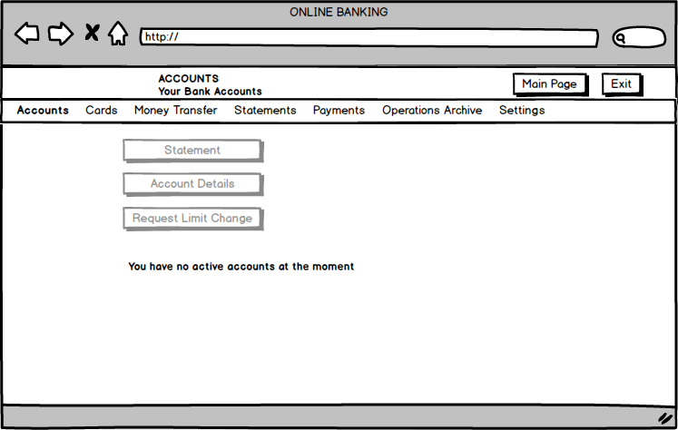

**Accounts screen - Customer has at least one Active Account**

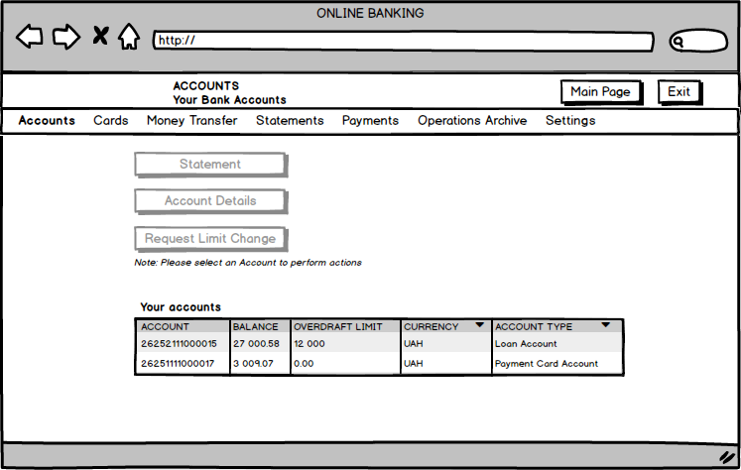

***Customer Application Accounts Table of Elements***

|  |  |  |  |  |  |  |  |
| --- | --- | --- | --- | --- | --- | --- | --- |
| **##** | **Label** | **Data Type** | **Control Type** | **Rule** | **Mandatory/Optional** | **Default Value/ State** | **Description** |
| **1** | **Exit** |  | Button |  |  | Enabled | When **Exit** is clicked, User is navigated to Login Page. |
| **2** | **Main Page** |  | Button |  |  | Enabled | When **Main Page** is clicked, User is navigated to Main Page. |
| **3** | **Menu** |  | Group of hyperlinks in Menu header | BRCMP001 |  | Enabled | Allows navigation to any menu item. |
| **4** | **Page title** |  | Label |  |  |  | Consists of the phrase "ACCOUNTS  Your Bank Accounts" |
| **5** | **Statement** |  | Button | BRCAP001 |  | Disabled | **Statement** button is enabled when User selects an account in **Your accounts** table. When User clicks **Statement** the **Account Statements** window pops up. |
| **6** | **Account Details** |  | Button | BRCAP002 |  | Disabled | **Account Details** button is enabled when User selects an account in **Your accounts** table. When User clicks **Account Details** the **Account Details** window pops up. |
| **7** | **Request Limit Change** |  | Button | BRCAP003 |  | Disabled | **Request Limit Change** button is enabled when User selects an account in **Your accounts** table. When User clicks **Request Limit Change** the **Limit Change Request** window pops up. |
| **8** | **Your accounts** | Multiple | Table | BRCAP004  BRCAP005  BRCAP006 |  |  | A table displaying all active accounts of the Customer User.  Columns width should be adjusted proportionally to size of browser’s window  Table rows are clickable - User should be able to select a single row. The selected row is highlighted. Table consists of the following columns:   * ACCOUNT - displays Account Number, * BALANCE - displays Account Balance, * OVERDRAFT LIMIT displays Account Limit, * CURRENCY - displays Account Currency, sortable * ACCOUNT TYPE - displays Account Type, sortable.   Columns should reflect actual Customer information.  If Customer has no active accounts, **Your accounts** table is hidden. |
| **9** | **Note** | String |  | BRCAP004 |  |  | Note is displayed above **Your accounts** table. Text displayed: “Note: Please select an Account to perform actions”.  If Customer has no active accounts, **Note** is hidden. |

***Customer Application Accounts Business Rules***

|  |  |  |
| --- | --- | --- |
| **Business rule** | **Action** | **Description** |
| BRCAP001 | User clicks **Statement** button. | The **Account Statements** window pops up. |
| BRCAP002 | User clicks **Account Details** button. | The **Account Details** window pops up. |
| BRCAP003 | User clicks **Request Limit Change** button. | The **Limit Change Request** window pops up. |
| BRCAP004 | User with no active accounts navigates to **Accounts** screen | System hides **Your accounts** table and **Note** and displays ‘You have no active accounts at the moment ’ message. |
| BRCAP005 | User with both active and inactive accounts navigates to **Accounts** screen. | System displays only active accounts in **Your accounts** table. |
| BRCAP006 | User clicks on any account row in **Your accounts** table. | System highlights selected row and enables **Statement**, **Account Details** and **Request Limit Change** buttons. |

### 2.4. Account Details pop-up

After customer user navigated to Accounts, user selects particular account from the list, clicks **Account Details** button and **Account Details** window pops up.

**General Information on Account Details pop-up window**

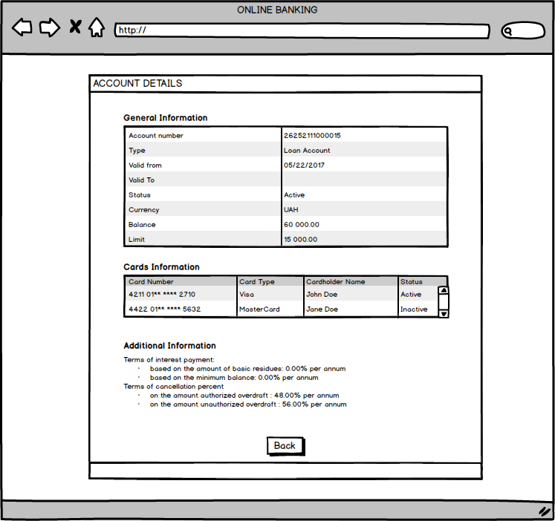

***Customer Application Account Details Table of Elements***

|  |  |  |  |  |  |  |  |
| --- | --- | --- | --- | --- | --- | --- | --- |
| **##** | **Label** | **Data Type** | **Control Type** | **Rule** | **Mandatory/Optional** | **Default Value/ State** | **Description** |
| **1** | **General Information** | Multiple | Table |  | BRCAD001 |  | A table displaying general information of the selected account.  Columns width should be adjusted proportionally to size of the window The below information is provided in the table:   * Account Number * Account Type * Valid From * Valid To * Status * Currency * Balance * Limit (for Loan accounts only)   Columns should reflect actual Customer information. |
| **2** | **Cards Information** | Multiple | Table |  |  |  | A table displaying information about all cards, assigned to the selected account.  Columns width should be adjusted proportionally to size of the window. A scrollbar should be shown in case table has more than 5 rows. The below information is provided in the table:   * Card Number - Number of the card with digits 7 to 12 replaced by asterisks. * Card Type * Cardholder Name * Status |
| **3** | **Additional Information** | String |  |  |  |  | A placeholder for interest rates of the account. Contains label ‘Additional Information’ and text:  ‘Terms of interest payment:  - based on the amount of basic residues: 0.00% per annum  - based on the minimum balance: 0.00% per annum  Terms of cancellation percent  - on the amount authorized overdraft : 48.00% per annum  - on the amount unauthorized overdraft : 56.00% per annum’ |
| **4** | **Back** |  | Button |  | BRCAD002 |  | When **Back** is clicked, User is navigated back to **Accounts** screen |

***Customer Application Account Details Business Rules***

|  |  |  |
| --- | --- | --- |
| **Business rule** | **Action** | **Description** |
| BRCAD001 | User opens **Account Details** for an account of other than Loan account type | System hides Limit row in **General Information** table. |
| BRCAD002 | User clicks **Back** button | User is navigated to Accounts page |

### 2.5. Cards Page

After customer user navigated to **Main Page** user clicks **Cards** in Menu section, and is navigated to **Cards** screen. User can also navigate to **Cards** screen by clicking any card row in **Your cards** table on **Main Page** (see BRCMP003).

User sees page title in the header. The header part is always visible.

Exit and Main Page buttons also located in the header.

Menu is located at the top of the screen, below the header. Menu is always visible.

**General Information on Cards screen**

**Cards screen - Customer has no Cards**

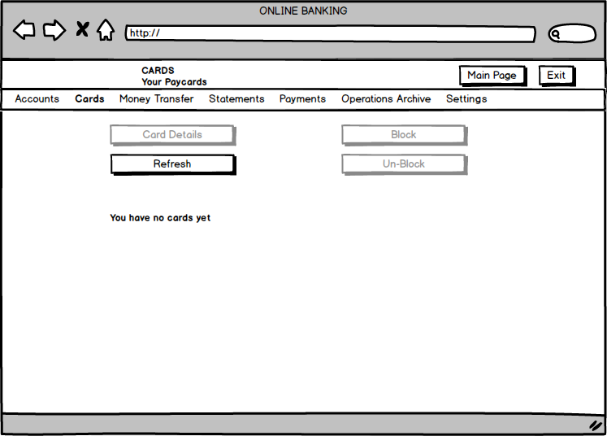

**Cards screen - Customer has at least one Card**

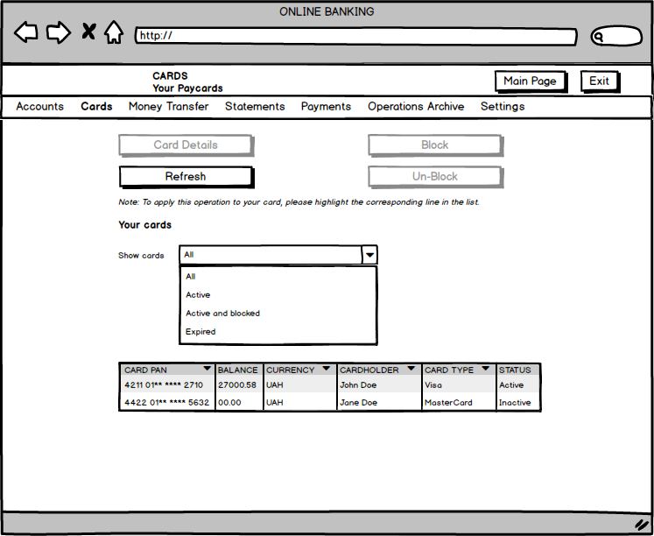

***Customer Application Cards Table of Elements***

|  |  |  |  |  |  |  |  |
| --- | --- | --- | --- | --- | --- | --- | --- |
| **##** | **Label** | **Data Type** | **Control Type** | **Rule** | **Mandatory/Optional** | **Default Value/ State** | **Description** |
| **1** | **Exit** |  | Button |  |  | Enabled | When **Exit** is clicked, User is navigated to Login Page. |
| **2** | **Main Page** |  | Button |  |  | Enabled | When **Main Page** is clicked, User is navigated to Main Page. |
| **3** | **Menu** |  | Group of hyperlinks in Menu header | BRCMP001 |  | Enabled | Allows navigation to any menu item. |
| **4** | **Page title** |  | Label |  |  |  | Consists of the phrase "CARDS  Your Paycards" |
| **5** | **Card Details** |  | Button | BRCPC001 |  | Disabled | **Card Details** button is enabled when User selects a card in **Your cards** table. When User clicks **Card Details** the **Card Details** window pops up. |
| **6** | **Refresh** |  | Button | BRCPC002 |  | Enabled | When User clicks **Refresh,** the system updates cards information on the **Cards** screen. |
| **7** | **Block** |  | Button | BRCPC003 |  | Disabled | **Block** button is enabled when User selects an *active* card in **Your cards** table. When User clicks **Block,** the **Status of** the selected card is changed to ‘Blocked’. User cannot perform any transactions with this card. Card in Blocked status can be deactivated from admin and gets inactive upon **Expiration Date** similarly to active card. |
| **8** | **Un-Block** |  | Button | BRCPC004 |  | Disabled | **Un-Block** button is enabled when User selects a *blocked* card in **Your cards** table. When User clicks **Un-Block,** the **Status of** the selected card is changed to ‘Active’. |
| **9** | **Show cards** | String | Drop-down list | BRCPC005 BRCPC006 BRCPC007 BRCPC008 |  | All/Enabled | **Show Cards** allow user to filter cards displayed on UI by Status. Available values are:   * All * Active * Active and blocked * Expired |
| **10** | **Your cards** | Multiple | Table | BRCPC009  BRCPC010  BRCPC011 BRCPC012 |  |  | A table displaying all cards of the Customer User.  Columns width should be adjusted proportionally to size of browser’s window  Table rows are clickable - User should be able to select a single row. The selected row is highlighted. Table consists of the following columns:   * CARD PAN - displays Card Number, sortable, * BALANCE - displays Card Balance (balance of the account to which a card is assigned), * CURRENCY - displays card Currency, sortable, * CARDHOLDER - displays a Cardholder Name, sortable, * CARD TYPE - displays a Card Type, sortable, * STATUS - displays a status of the card: active, inactive or blocked.   Columns should reflect actual Customer information.  If Customer has no cards, **Your cards** table is hidden. |
| **11** | **Note** | String |  | BRCPC009 |  |  | Note is displayed above **Your cards** label. Text displayed: “Note: To apply this operation to your card, please highlight the corresponding line in the list.”.  If Customer has no cards, **Note** is hidden. |

***Customer Application Cards Business Rules***

|  |  |  |
| --- | --- | --- |
| **Business rule** | **Action** | **Description** |
| BRCPC001 | User clicks **Card Details** button. | The **Card Details** window pops up. |
| BRCPC002 | User clicks **Refresh** button. | System refreshes data on the screen. |
| BRCPC003 | User selects active card and clicks **Block** button. | System updates status of the selected card to ‘Blocked’. |
| BRCPC004 | User selects blocked card and clicks **Un-Block** button. | System updates status of the selected card to ‘Active’ |
| BRCPC005 | User selects ‘All’ in **Show cards** drop-down | System displays customer’s cards in all statuses in **Your cards** table |
| BRCPC006 | User selects ‘Active’ in **Show cards** drop-down | System displays customer’s cards in ‘Active’ status only in **Your cards** table |
| BRCPC007 | User selects ‘Active and blocked’ in **Show cards** drop-down | System displays customer’s cards in ‘Active’ and ‘Blocked’ statuses in **Your cards** table |
| BRCPC008 | User selects ‘Expired’ in **Show cards** drop-down | System displays customer’s cards in ‘Inactive’ status only in **Your cards** table |
| BRCPC009 | User with no cards navigates to **Cards** screen | System hides **Your cards** table and **Note** and displays ‘You have no cards yet ’ message. |
| BRCPC010 | User clicks on a row representing card in ‘Active’ status | System highlights selected row and enables **Card Details** and **Block** buttons. |
| BRCPC011 | User clicks on a row representing card in ‘Blocked’ status | System highlights selected row and enables **Card Details** and **Un-Block** buttons. |
| BRCPC012 | User clicks on a row representing card in ‘Inactive’ status | System highlights selected row and enables **Card Details** button. |

### 2.6. Card Details pop-up

After customer user navigated to Cards page, user selects particular card from the list, clicks **Card Details** button and **Card Details** window pops up.

**General Information on Card Details pop-up window**

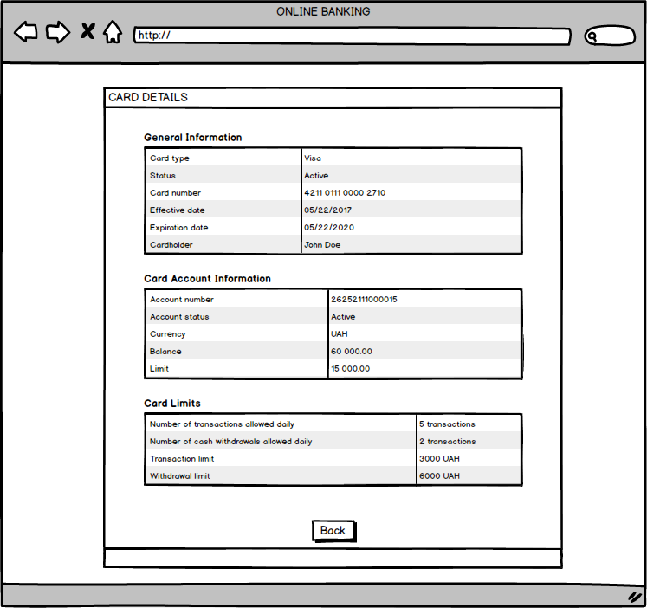

***Customer Application Card Details Table of Elements***

|  |  |  |  |  |  |  |  |
| --- | --- | --- | --- | --- | --- | --- | --- |
| **##** | **Label** | **Data Type** | **Control Type** | **Rule** | **Mandatory/Optional** | **Default Value/ State** | **Description** |
| **1** | **General Information** | Multiple | Table |  |  |  | A table displaying general information of the selected Card.  Columns width should be adjusted proportionally to size of the window The below information is provided in the table:   * Card Type * Status * Card Number * Effective Date * Expiration Date * Cardholder   Columns should reflect actual Customer information. |
| **2** | **Card Account Information** | Multiple | Table |  | BRCCD001 |  | A table displaying information about the account selected card is assigned to.  Columns width should be adjusted proportionally to size of the window.  The below information is provided in the table:   * Account number * Account status * Currency * Balance * Limit (for Loan accounts only) |
| **3** | **Card Limits** | Multiple | Table |  | BRCCD002 |  | A table displaying information about the Limits for the selected card. (currently a placeholder)  Columns width should be adjusted proportionally to size of the window.  The below information is provided in the table:   * Number of transactions allowed daily * Number of cash withdrawals allowed daily * Transaction limit - amount in the currency of the account * Withdrawal limit - amount in the currency of the account |
| **4** | **Back** |  | Button |  | BRCCD003 |  | When **Back** is clicked, User is navigated back to **Cards** screen |

***Customer Application Card Details Business Rules***

|  |  |  |
| --- | --- | --- |
| **Business rule** | **Action** | **Description** |
| BRCCD001 | User opens **Cards Details** for a card assigned to an account of other than Loan account type | System hides Limit row in **Card Account Information** table. |
| BRCCD002 | User opens **Cards Details** | System displays currencies same as account currency in Transaction limit and Withdrawal limit in **Card Limits** table. |
| BRCCD003 | User clicks **Back** button | User is navigated to Cards page |

### 2.7. Money Transfer screen

After customer user navigated to Main Page, Accounts or Cards page, user clicks **Money Transfer** button in Menu bar and is navigated to **Money Transfer** screen**.**

**General Information on Money Transfer screen**

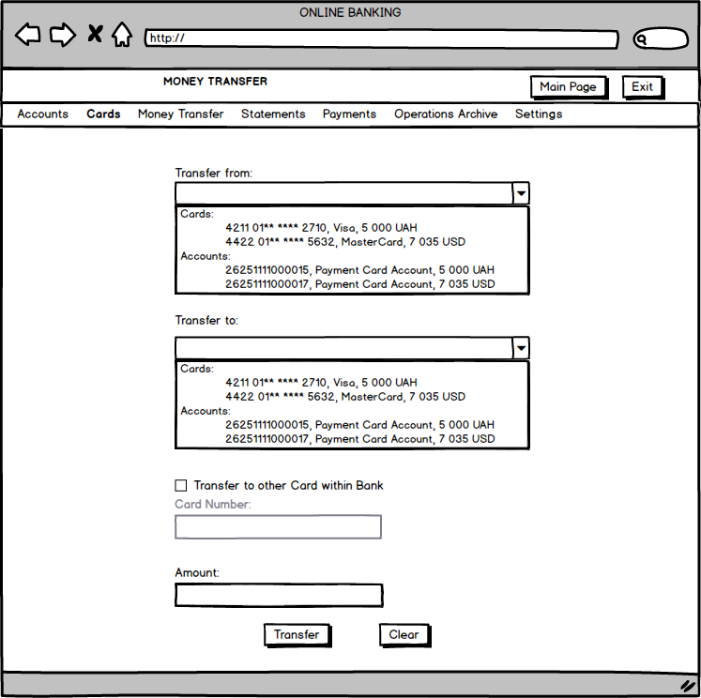

**Money Transfer screen - Customer has no active Accounts**

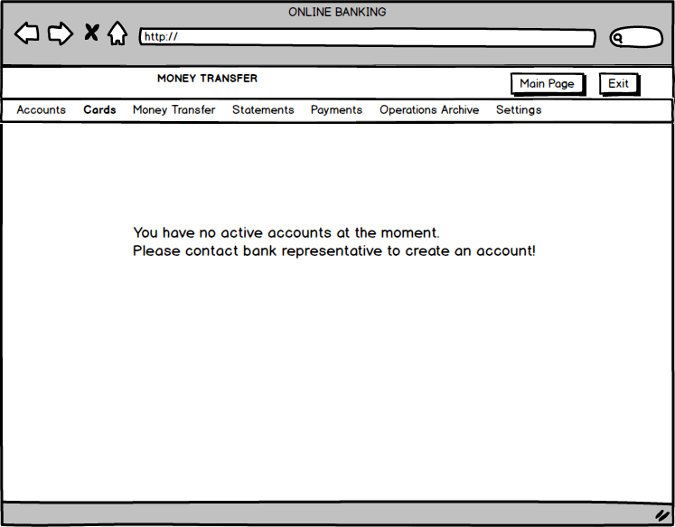

**Successful Money Transfer pop-up**

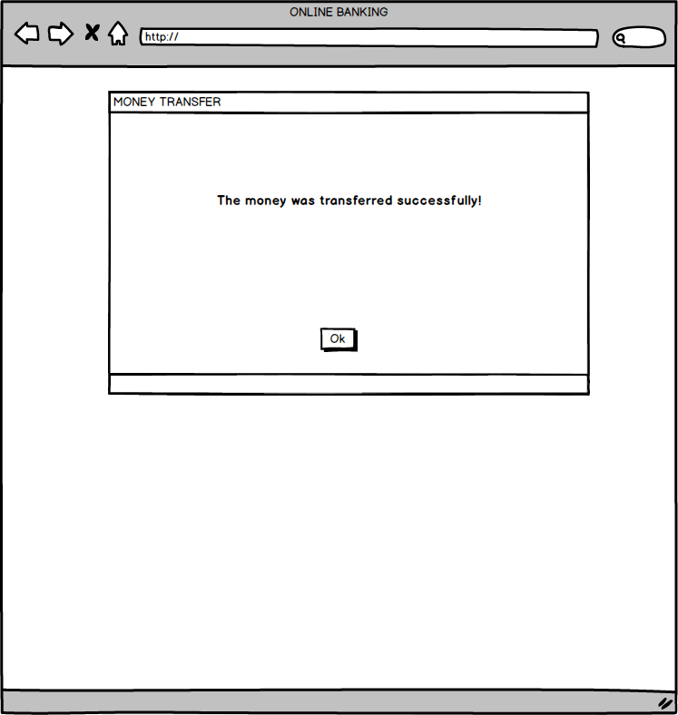

***Customer Application Money Transfer Table of Elements***

|  |  |  |  |  |  |  |  |
| --- | --- | --- | --- | --- | --- | --- | --- |
| **##** | **Label** | **Data Type** | **Control Type** | **Rule** | **Mandatory/Optional** | **Default Value/ State** | **Description** |
| **1** | **Exit** |  | Button |  |  | Enabled | When **Exit** is clicked, User is navigated to Login Page. |
| **2** | **Main Page** |  | Button |  |  | Enabled | When **Main Page** is clicked, User is navigated to Main Page. |
| **3** | **Menu** |  | Group of hyperlinks in Menu header | BRCMP001 |  | Enabled | Allows navigation to any menu item. |
| **4** | **Transfer from:** | Multiple | Drop-down list | BRCMT001  BRCMT002  BRCMT003 | M | Empty/Enabled | Card or Account from which User wants to transfer Money. Drop-down shows two categories:  Cards - represents active customer’s cards in format: Card Number, Card Type, Balance+’ ’+Currency;  Account - represents active customer’s accounts in format: Account Number, Account Type, Balance+’ ’+Currency; |
| **5** | **Transfer to:** | Multiple | Drop-down list | BRCMT002  BRCMT003  BRCMT004 | M | Empty/Enabled | Card or Account to which User wants to transfer Money. Drop-down shows two categories:  Cards - represents active customer’s cards in format: Card Number, Card Type, Balance+’ ’+Currency;  Account - represents active customer’s accounts in format: Account Number, Account Type, Balance+’ ’+Currency; Cannot be the same as **Transfer From** (in terms of Account)**.** |
| **6** | **Transfer to other Card within Bank** |  | Checkbox | BRCMT009 |  | Unchecked/Enabled | Indicates if money transfer is to the other customer’s card within the Bank. When **Transfer to other Card within Bank** is clicked, value selected in **Transfer to** is cleared (if any), **Transfer to** is disabled and **Card Number** is enabled. |
| **7** | **Card Number** | Integer | Input | BRCMT009  BRCMT010  BRCMT011  BRCMT012  BRCMT013 | M (when enabled) | Empty/Disabled | 16-digit Card identifier of the card User intends to transfer money to. |
| **8** | **Amount:** | Double | Input | BRCMT005  BRCMT006  BRCMT007 | M | Empty/Enabled | Positive amount that User wants to transfer. |
| **9** | **Transfer** |  | Button | BRCMT008 |  | Enabled | When User clicks **Transfer**, the System validates all fields and in case of successful validation - moves stated amount from one account to another. Transaction date, amount, accounts and transaction type is stored in DB for reporting purposes. |
| **10** | **Clear** |  | Button |  |  | Enabled | When User clicks **Clear,** all entered data is cleared. |
| **8** | **Ok** |  | Button |  |  | Enabled | If Ok button in Successful Money Transfer pop-up is clicked, Pop-up is closed. |

***Customer Application Money Transfer Business Rules***

|  |  |  |
| --- | --- | --- |
| **Business rule** | **Action** | **Description** |
| BRCMT001 | User does not select **Transfer from** and clicks **Transfer.** | System detects that **Transfer from** is empty and displays error message “Please select Transfer from Card or Account.” |
| BRCMT002 | User selects **Transfer from** and **Transfer to** items, that refer to the same account and clicks **Transfer.** | System detects that **Transfer from** and **Transfer to** items refer to the same account and displays error message “‘Transfer from’ and ‘Transfer to’ should not refer to the same account. Please update ‘Transfer from’ or ‘Transfer to’.” |
| BRCMT003 | User selects **Transfer from** and **Transfer to** items, with different Currency and clicks **Transfer.** | System detects that **Transfer from** and **Transfer to** are of different Currency and displays error message: “Sorry, money transfer with currency exchange is not available at the moment.“ |
| BRCMT004 | User does not select **Transfer to** and clicks **Transfer.** | System detects that **Transfer to** is empty and displays error message “Please select Transfer to Card or Account.” |
| BRCMT005 | User does not select  **Amount** and clicks **Transfer.** | System detects that **Amount** is empty and displays error message “Please specify the transfer amount.” |
| BRCMT006 | User enters **Amount** that is greater than Balance+Limit of the account/card selected in **Transfer from** and clicks **Transfer.** | System detects that **Amount** is too big and displays error message “Amount exceeds available balance.”  Note: Balance+Limit formula is correct for all accounts, for non-loan accounts type Limit is zero. Please pay attention to correct processing of loan accounts with negative balance. |
| BRCMT007 | User enters negative amount or symbols other than numbers to **Amount** field and clicks **Transfer.** | System detects that **Amount** format is not correct and displays error message “Amount should be a positive monetary value.” |
| BRCMT008 | User enters valid data to all fields and clicks **Transfer.** | System transfers the specified amount from **Transfer from** item to **Transfer to** item by updating Balance of the corresponding items by the specified amount. System stores the transaction information:   * Transaction date/time - current system date and time * Transaction type - ‘Money Transfer’ * Transaction subtype - ‘Between own accounts’ or ‘Within Bank’ * Credit Account - Account number of the **Transfer from** item * Debit Account - Account number of the **Transfer to** item * Transaction Amount - Amount transferred * Transaction Currency - Currency * Transaction location - ‘Online Banking’ * Transaction Performer - Current User * Starting and ending balance for each of the accounts. * If applicable - Cards from and to which Money are transferred.   Note:Suggestion here is to store two records for each transaction: for Account money are transferred from and for Account where money are allocated, use an Entry Type (Credit or Debit) to indicate this. Overall data model is up to you, but we should be able to get the described above data to show operations archive in the future.  Successful Money Transfer window pops up with enabled Ok button. |
| BRCMT009 | User checks the  **Transfer to other Card within Bank** | System clears and disables **Transfer to** and enables **Card Number.** |
| BRCMT010 | User enters other than 16-digit numeric value to **Card Number** and clicks **Transfer.** | System detects that Card number is invalid and displays error message: “Card Number should be a 16-digit numeric value.” |
| BRCMT011 | User checks the  **Transfer to other Card within Bank,** does not enter **Card Number** and clicks **Transfer**. | System detects that Card number is missing and displays error message: “Card Number is mandatory.” |
| BRCMT012 | User enters **Card Number** that does not exist in the System or that is expired or blocked and clicks **Transfer**. | System detects that Card number does not exist in the System and displays error message: “Card Number is not found or the Card is expired/blocked. Please try another Card Number”. |
| BRCMT013 | User enters **Card Number** of his own Card and clicks **Transfer**. | System detects that Card refers to the User and and displays error message: “To transfer money to your Card, please uncheck the ‘Transfer to other Card within Bank’ and select the Card from drop-down list.” |
| BRCMT014 | User with no active accounts navigates to **Money Transfer** screen. | System detects that current User has no active accounts and displays message:  “You have no active accounts at the moment.  Please contact bank representative to create an account!”. All fields at **Money Transfer** screen are hidden. |

# Styling Rules

This section describes Online Banking application styling rules and elements used in application.

## Rules applying to error messages

1.1. Error messages are displayed below the input fields which they are related to.

1.2. Error messages are in red.

1.3. Corresponding input fields are highlighted with red.

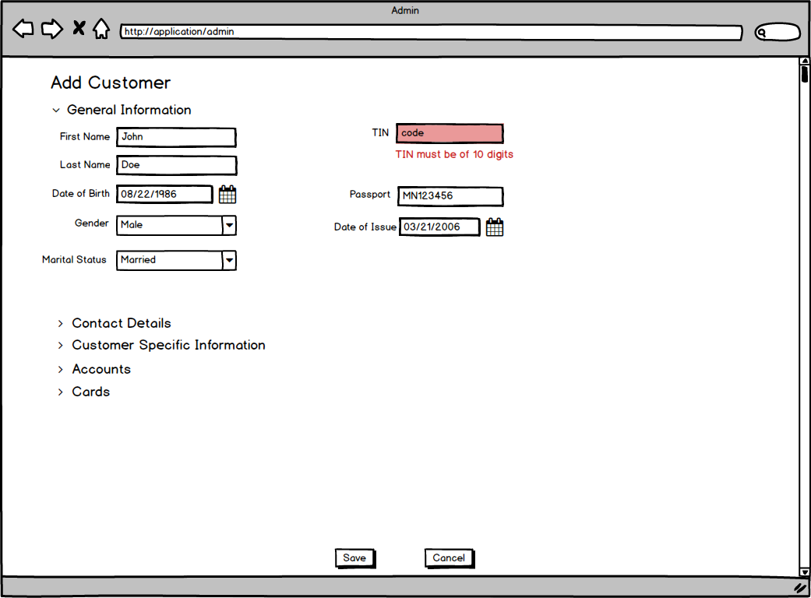

1.4. Error messages arising from issues in business logic are displayed at the bottom of the page / form on which the issues occur.

1.5. Error message disappears after the input field it relates to is cleared.

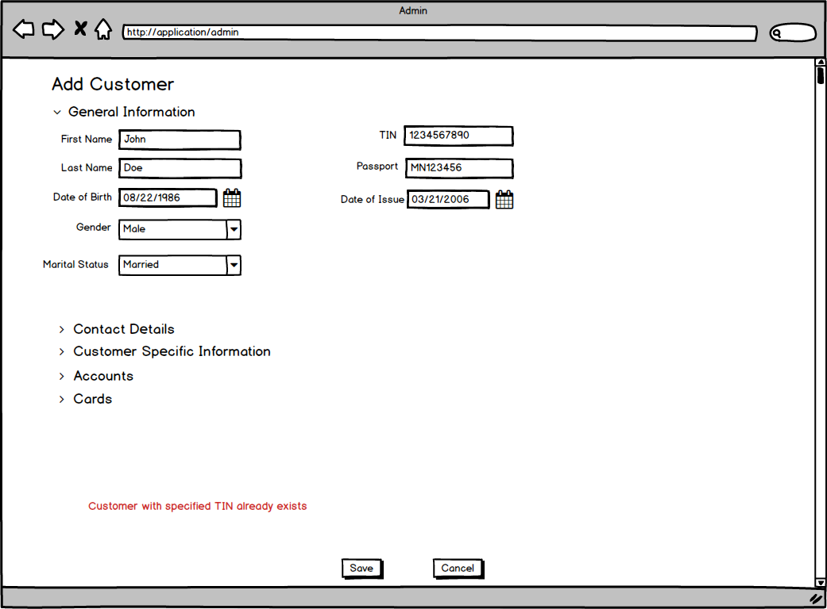

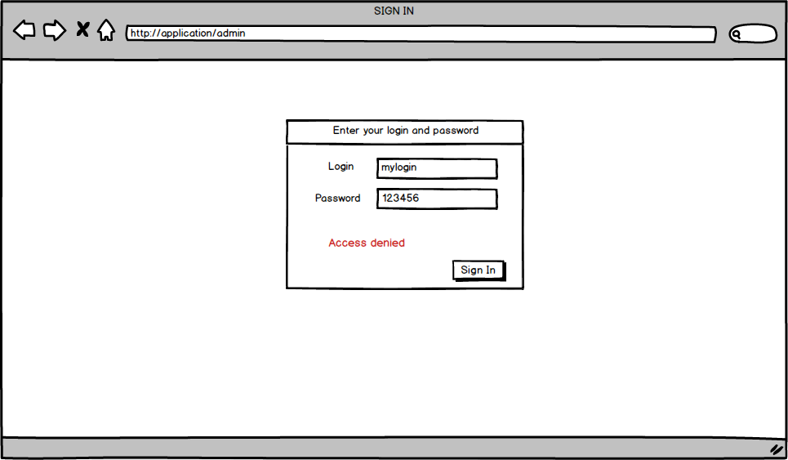

## Rules applying to input fields

2.1. Spaces in the beginning of the entered string should be trimmed upon clicking the Save button, before validation and saving to database.